GOAMA PLAYBOOK Version 2.0

The purpose of this document is to help guide in configuration and setting up different features and the functions existing within the Goama Tournament Platform.

# What is the Goama Tournament Platform?

The Goama Tournament Platform is our solution in making your apps and sites more fun and engaging by Gamifying your platform. We achieve this “Gamification” by using the craft of deriving fun and addictive elements usually found in games to apply this to your platform in productive, fun and engaging ways to boost performance.

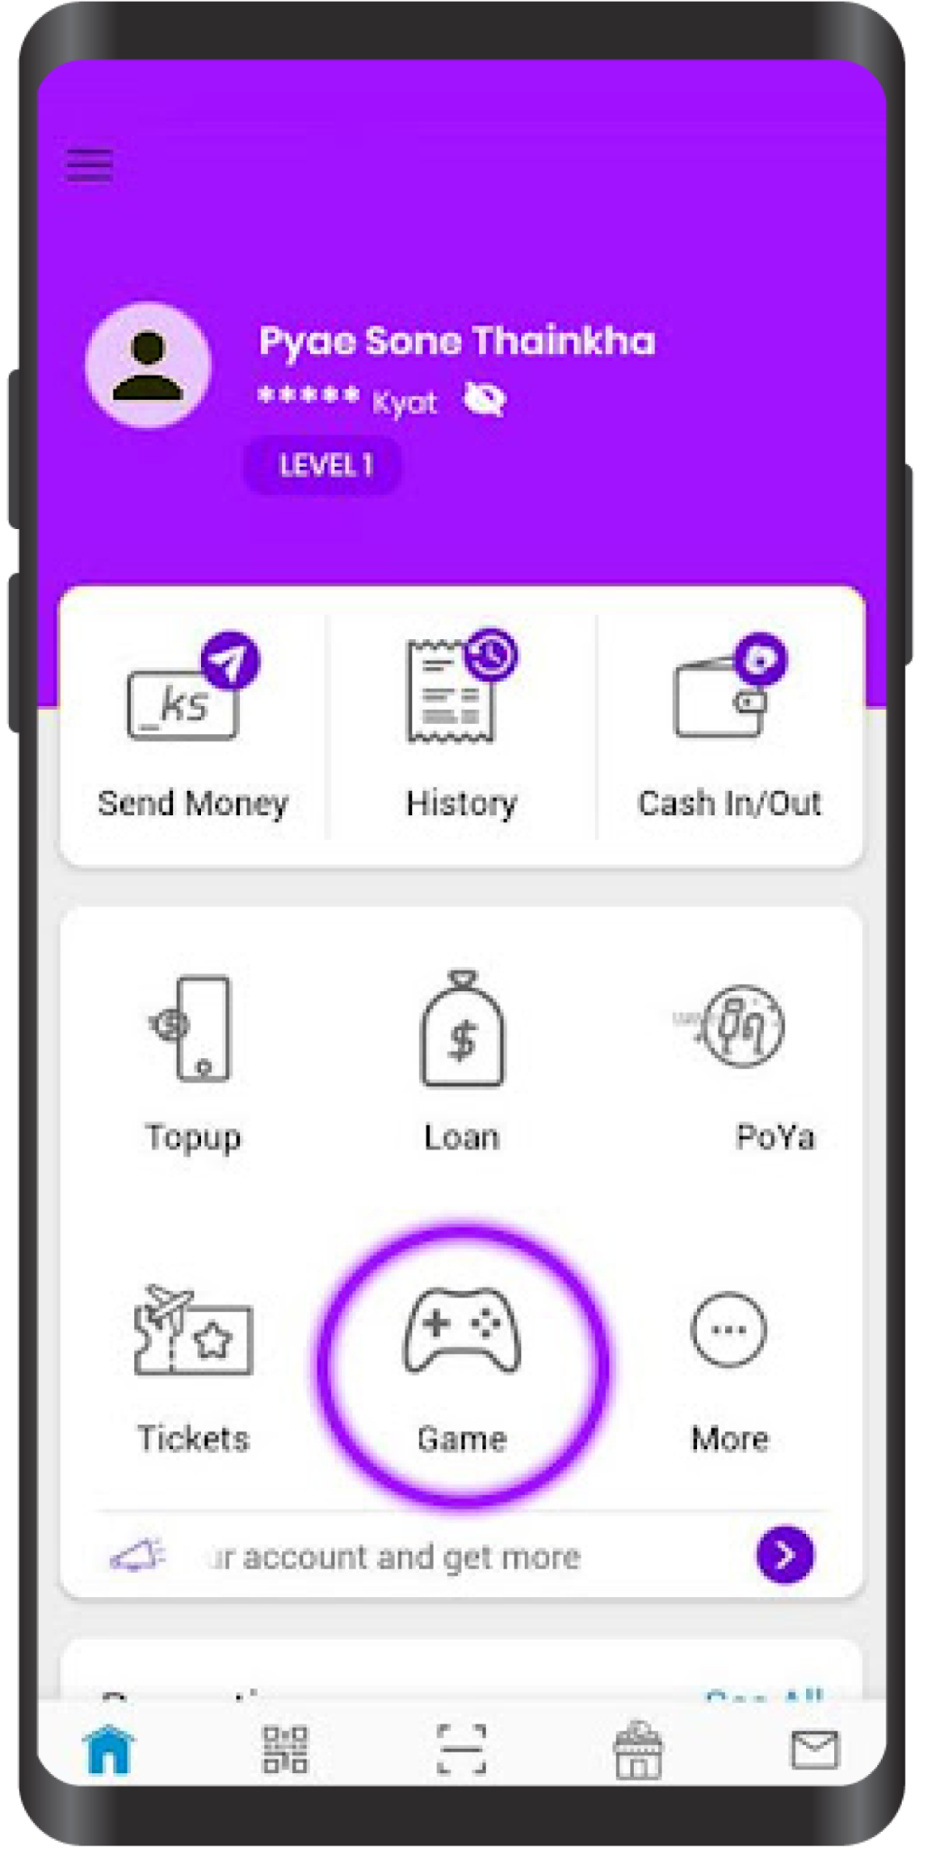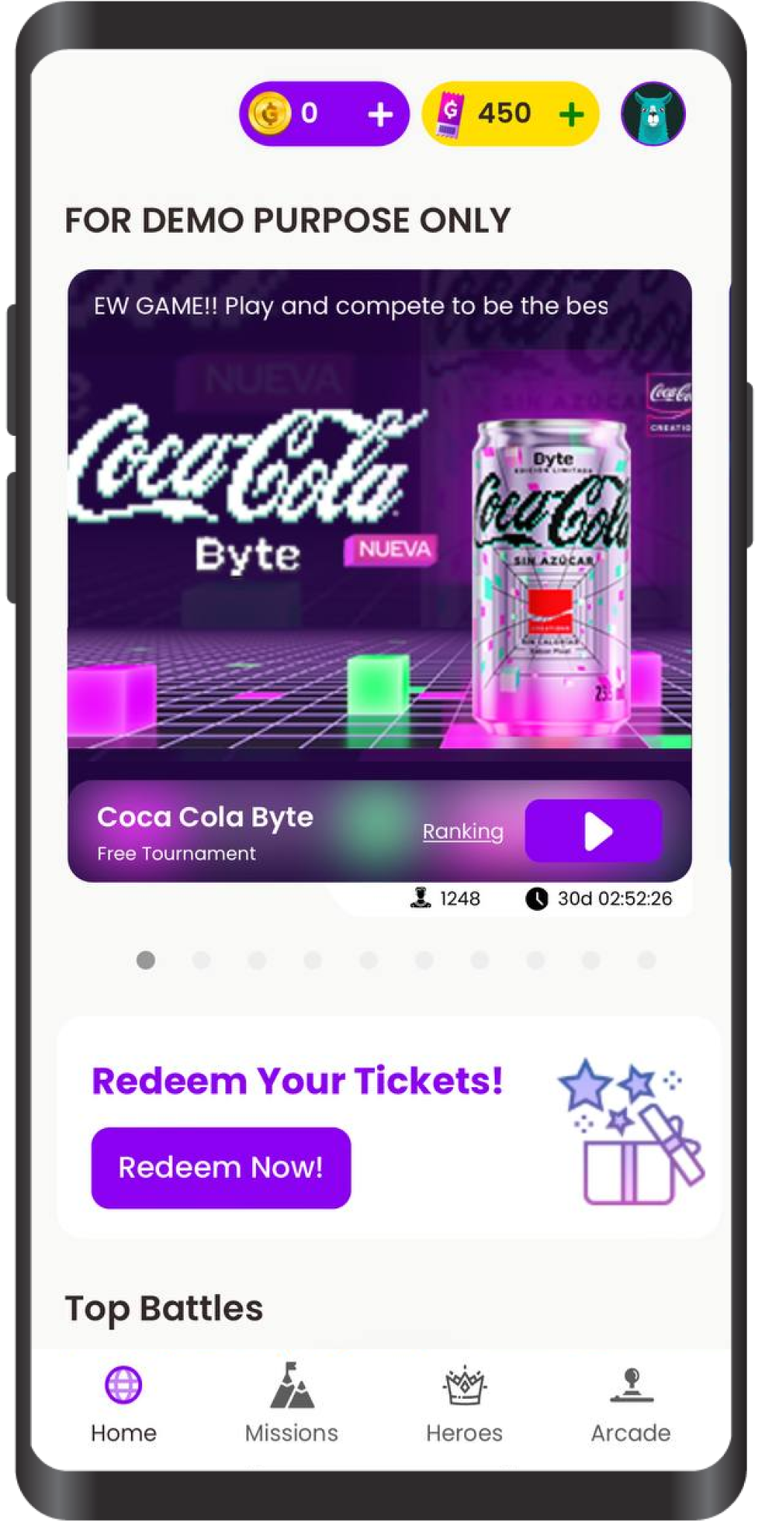

# Do you want to integrate with us ?

To get this and integrate to your platform please see details of integration [here](https://docs.google.com/document/d/1vCOV8iFwWJYhPr05dLcFRhvSSKvM9DbYbUY8KtjPC0w/edit).

**The 4 Key Sections**

Goama Tournament mainly consists of 4 mains sections as of now.

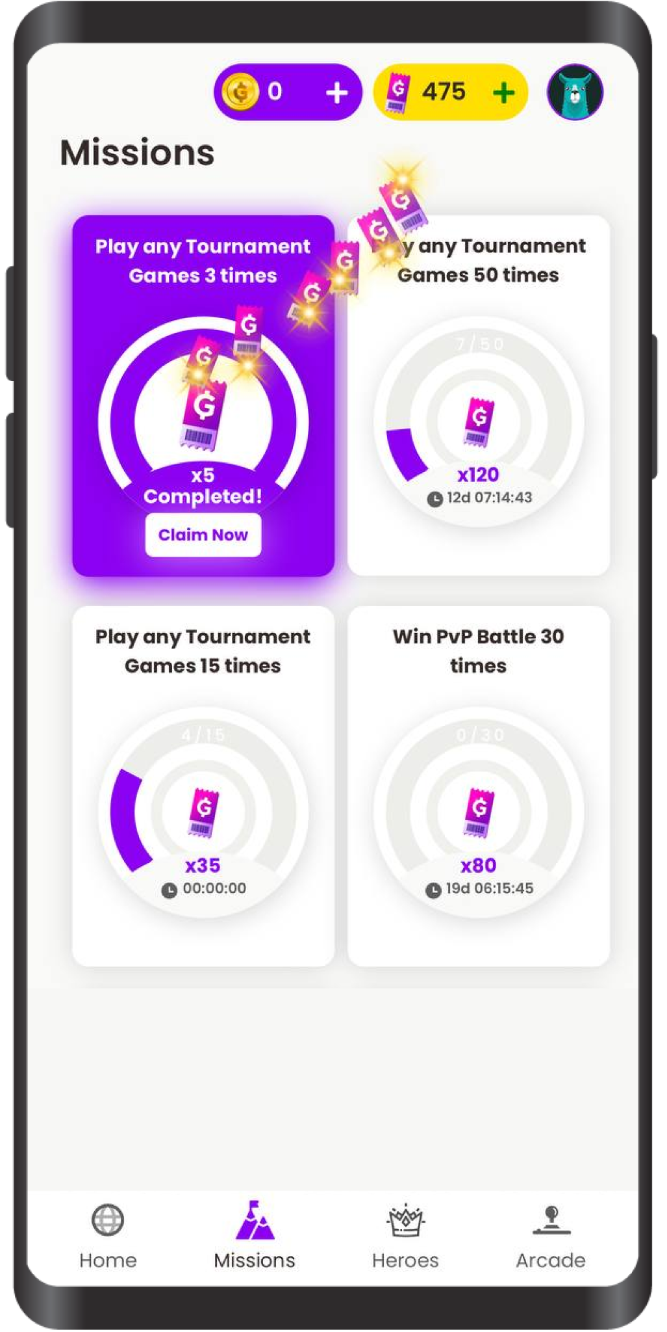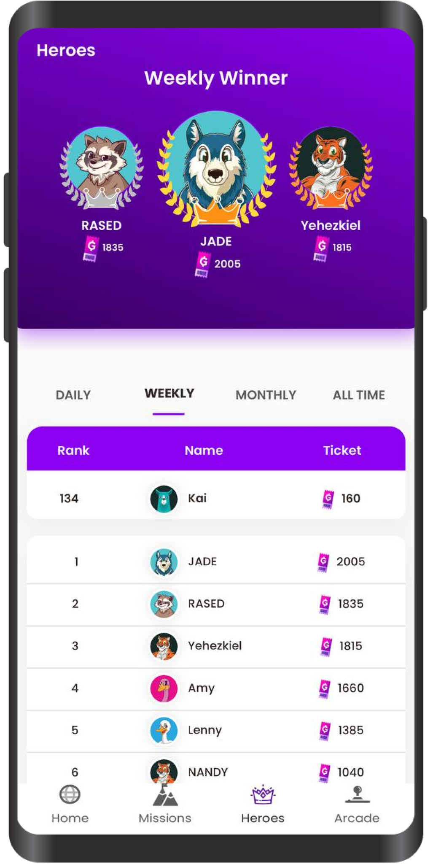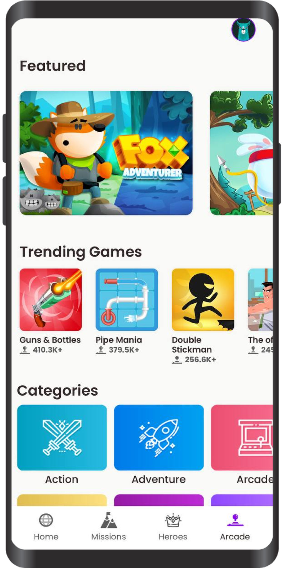

1. Home Page
2. Mission Page
3. Heroes Page
4. Arcade Page

## 

## 

## Home Page

What makes up the Home Page?

The game section is the first page a user sees when they enter the platform.

The Game section consists of the following parts:

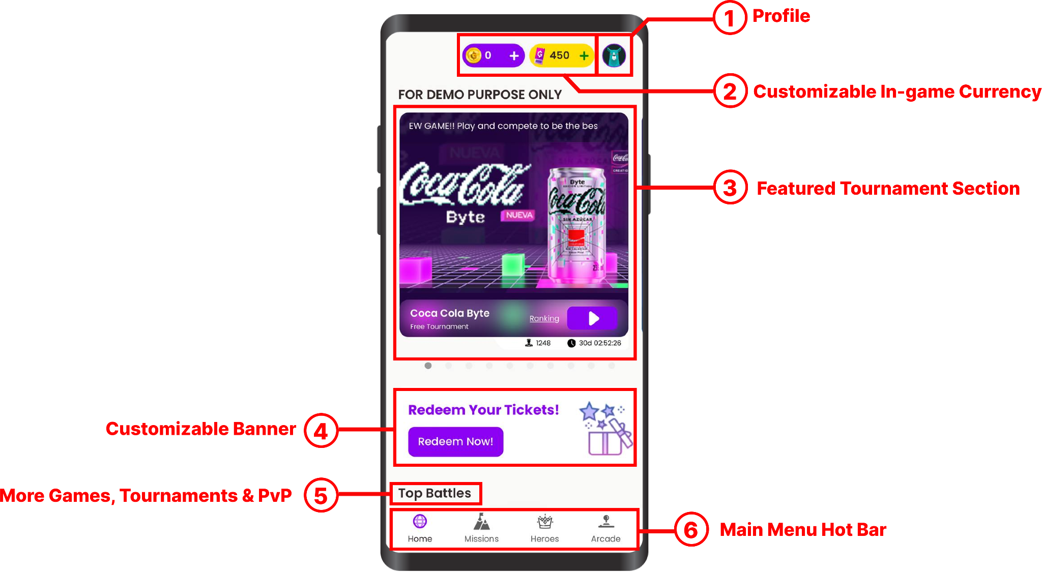

1. User Personal Profile
2. Customizable In-Game Currency (See Tickets & Coins)
3. Highlighted Tournaments for players to keep and eye out for
4. Customizable banners for redirecting specific pages or promotional contents.
5. Scroll down for more games,tournaments & PvP
6. Navigate through key sections of our platform

## Achievements & Mission Page

Achievements & Missions are a form of in-game task and challenges players can complete to earn extra rewards such as tickets or unlock collectibles such as badges to display to other players.



## Heroes Page

The hero section is our global leaderboard shared between players in the region. Players can see and compare their ranking versus other top players in the region. The leaderboard tracks the amount of Heroes Point a player earns from playing tournaments. Hero points are earned by player’s winning, ranking and performance in participating Tournaments across the Platform. This section also Highlights the Top 3 Players for each category.   
(Daily, Weekly, Monthly & All-Time).   
  
After each specific period, the rankings get refreshed (except for All Time)



her

## Arcade Page

Arcade section is available for players who want to go even more casual gameplay. Just click to play from a library of hundreds games. The games are free to play and does not have Leaderboards.



# Other Notable Sections

## Profile Page

The profile page shows the detailed information about a user such as their level and statistics related to their games. Tournament history can be also found and your personal information and profile pictures or avatar can be customized as well.   
  
This page is where all your important stats can be found.

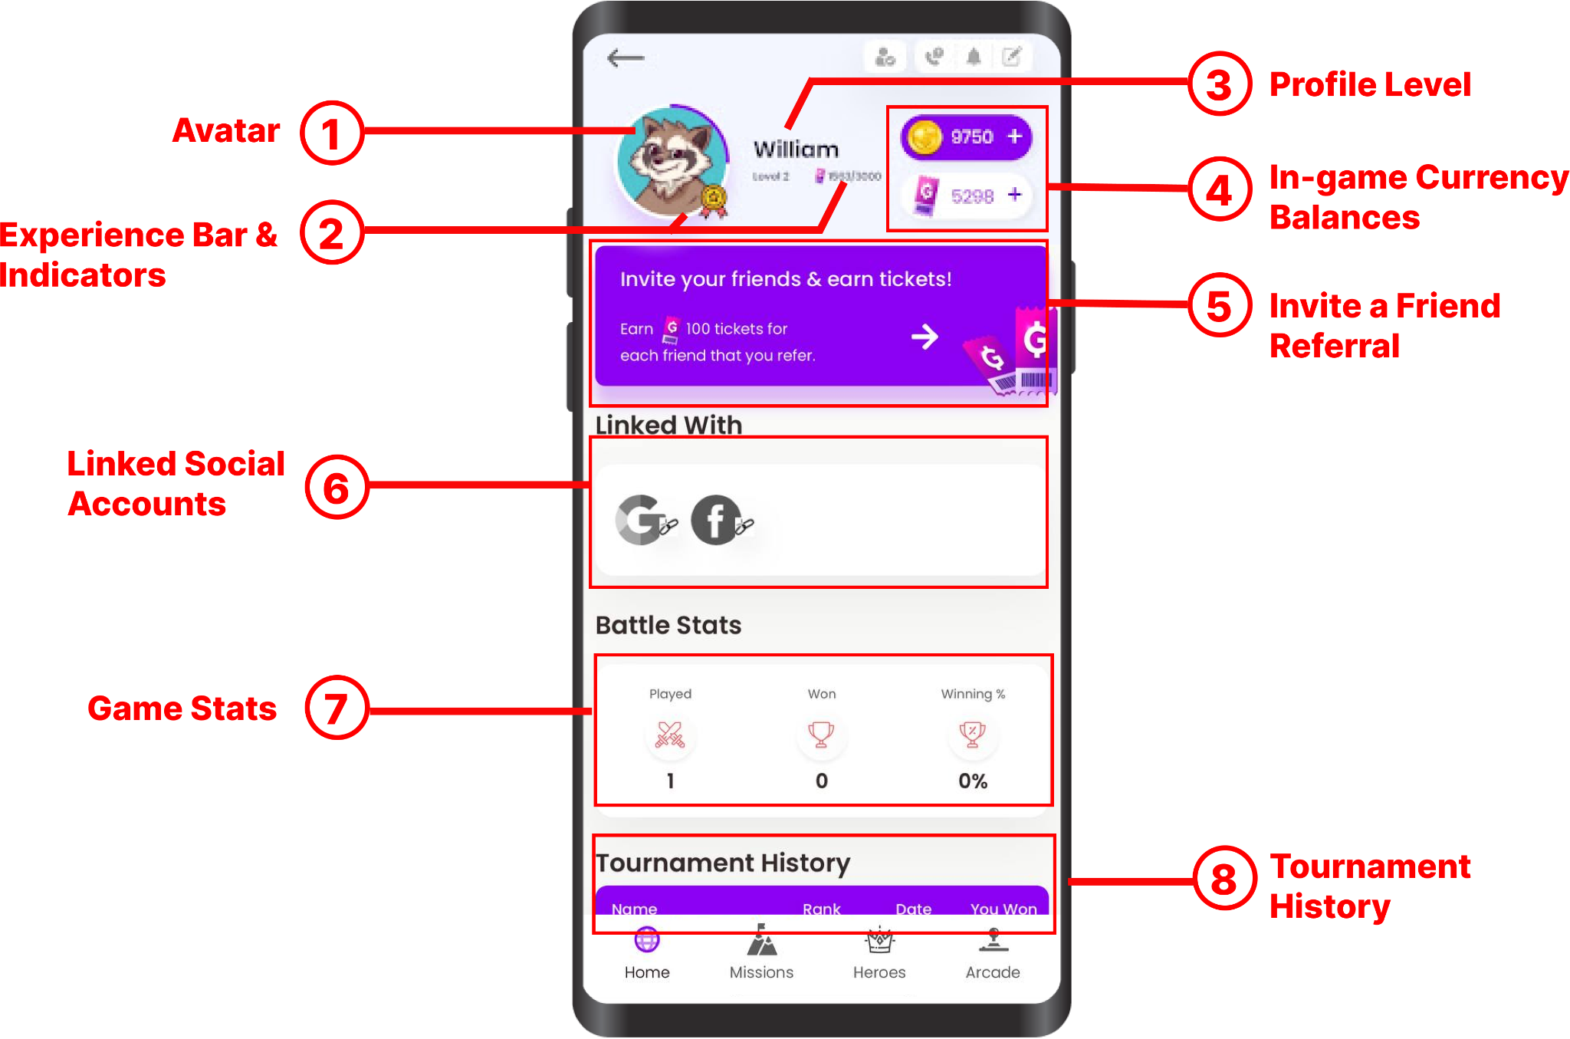

**Tournament Info Page**

**Game Over Page**

**Core Features & Configurations**

# Setting Up Platform

**Why do we need to set up the platform?**

Before you can start creating your tournaments it is vital to set up your Platform. To achieve this, prior integrations need to be done.

(For integration - click here)

Setting up the platform is necessary as it includes basic and general configuration settings that are required for the Platform to work and tournaments to be created.

We complete this process through the use of an Admin Portal (Django Admin Portal), soon to be replaced with Goama Software As A Service Portal (GSAAS Portal). To learn more about (GSAAS) - click here.

The first step in setting up a platform, we need to create an instance or application for a specific partner. The application settings section includes other configurations but to create an instance simply enter name and save the settings.

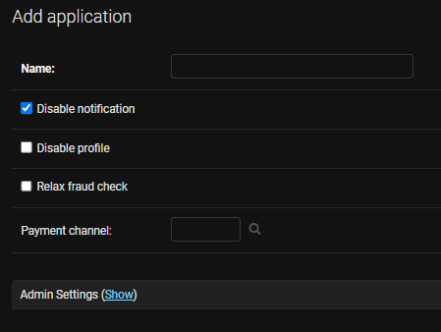

# Leaderboard Tournaments

### Different Types of Tournament

* Free/Sponsored Tournament
* Paid Tournament
* Try Based Tournament
* Exclusive Tournaments

## Free & Sponsored Tournaments

### User Journey

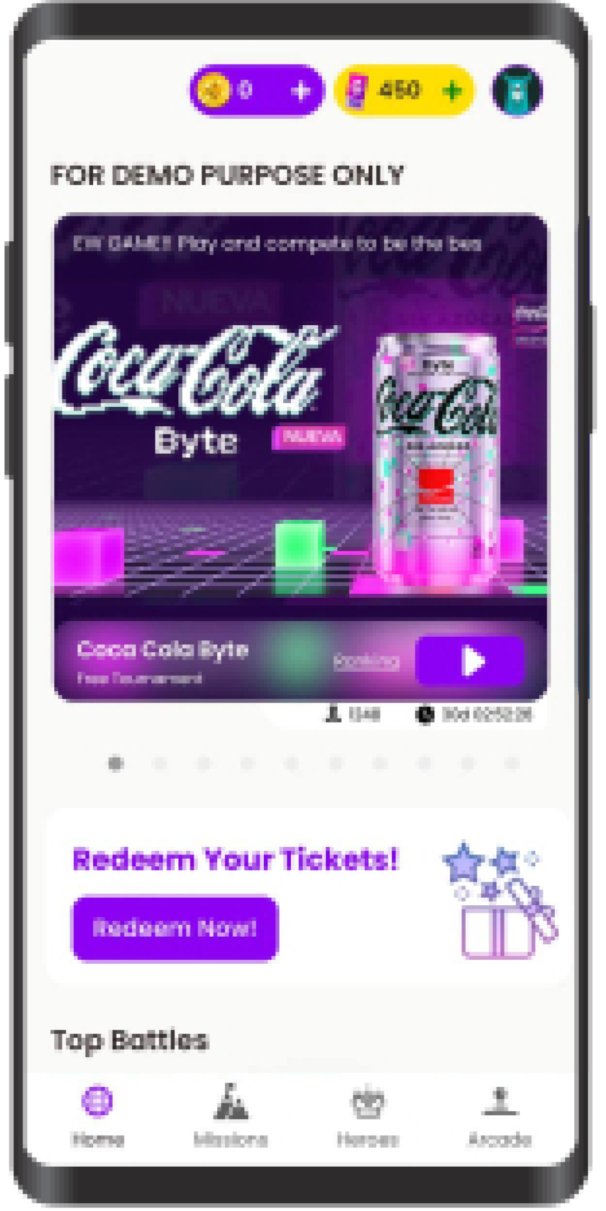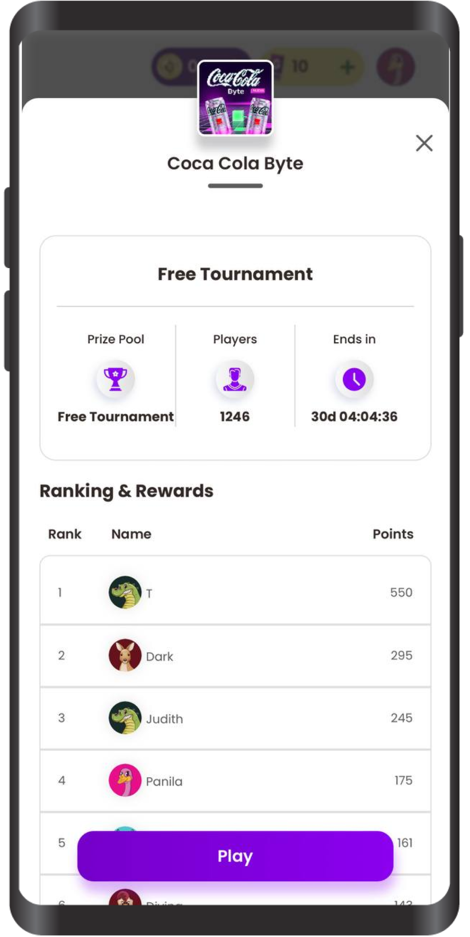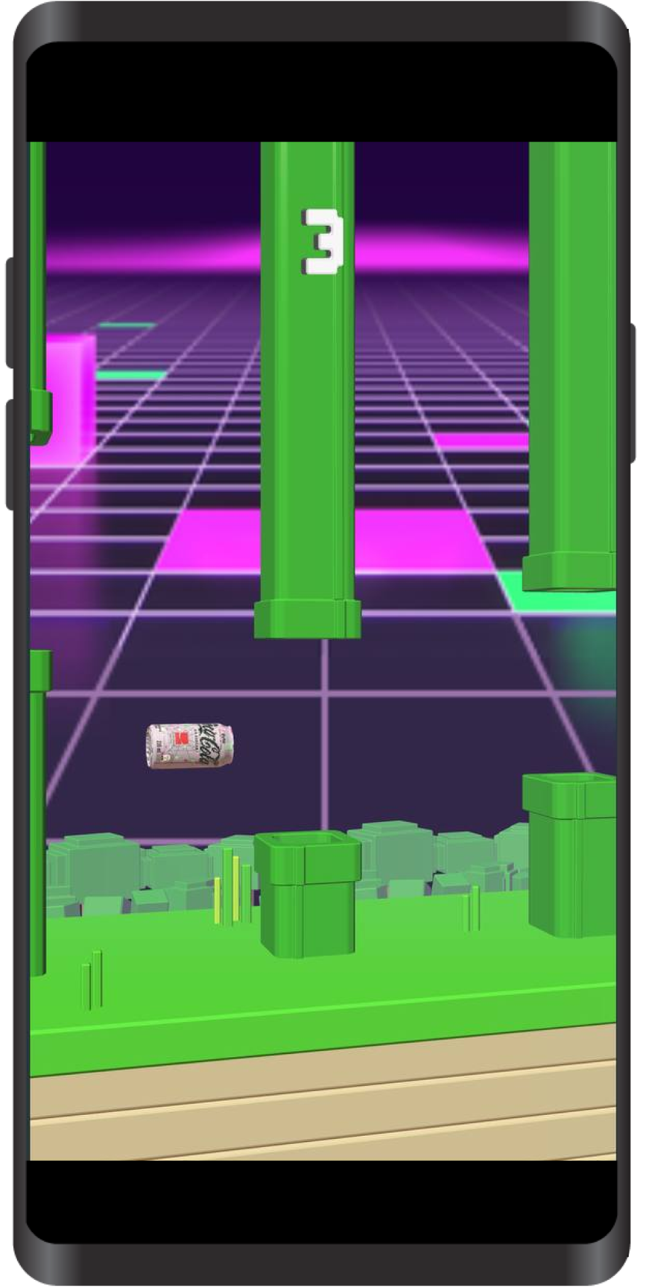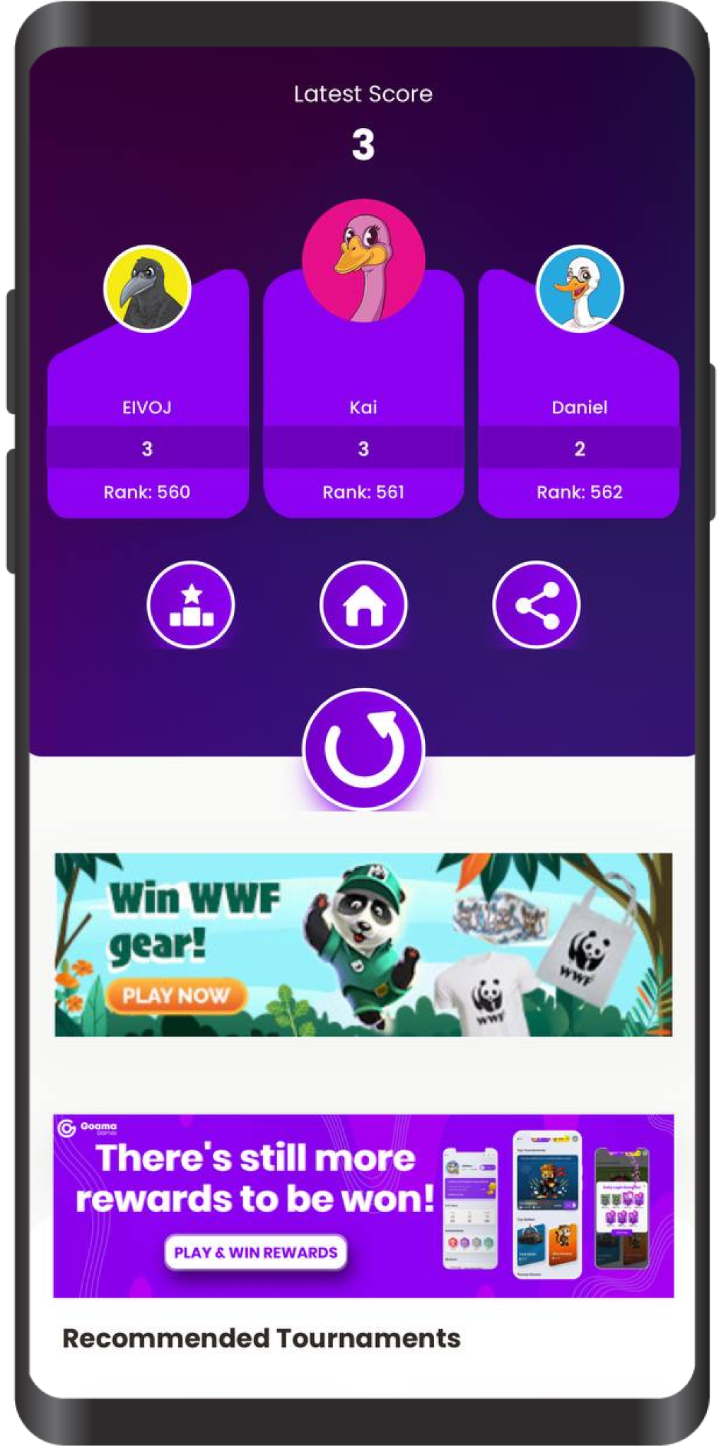

### Configurations & Setups

**Log into your Django Portal > Under Tournaments Section > Click on Tournaments > Add Tournament**

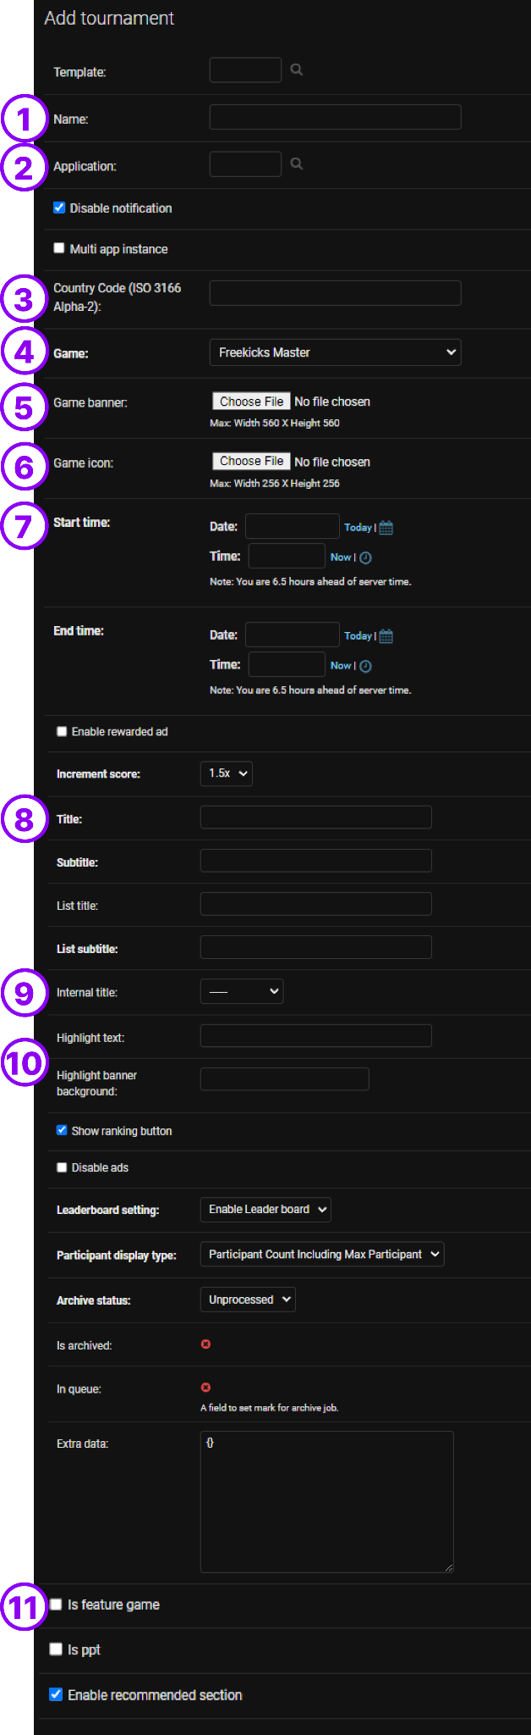

1. Enter the Name of the Tournament (Internal name)
2. Select the application of a partner that you have previously created to enable this tournament in that instance.
3. Enter the country code of the instance you want this tournament to be enabled.
4. Select the Game
5. Upload the game banner if you have one, if not default will be used.
6. Upload the game icon if you have one, if not default will be used.
7. Select the Start/End Date & Time for this tournament
8. Enter Title, Subtitles, List Titles, List Subtitles to name or change general information of the tournament that will appear in the live platform.
9. Select Category of the nature of Tournament (A must required for Internal purpose)
10. Customizable Highlight text and color can also be applied
11. To Top-Feature the tournament please check (is feature game)

## Paid Tournaments

### User Journey

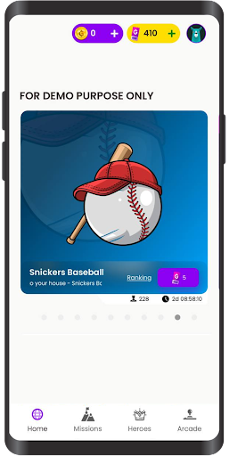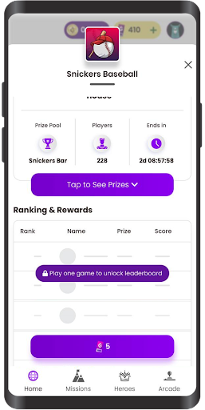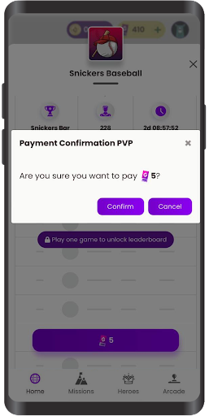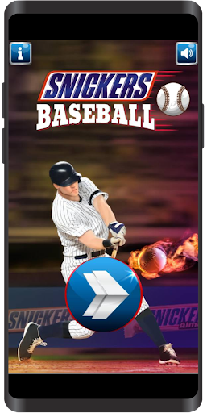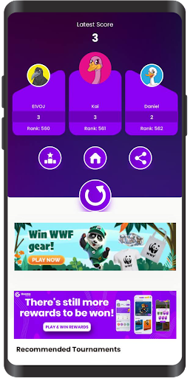

### Different types of Paid Tournaments

* Manual or Fixed Prize
* Automatic Prize
* Dynamic Prize

### Configurations & Setups

#### Manual or Fixed Prize

**Log into your Django Portal > Under Tournaments Section > Click on Tournaments > Add Tournament**



1. Enter the Name of the Tournament (Internal name)
2. Select the application of a partner that you have previously created to enable this tournament in that instance.
3. Enter the country code of the instance you want this tournament to be enabled.
4. Select the Game
5. Upload the game banner if you have one, if not default will be used.
6. Upload the game icon if you have one, if not default will be used.
7. Select the Start/End Date & Time for this tournament
8. Enter Title, Subtitles, List Titles, List Subtitles to name or change general information of the tournament that will appear in the live platform.
9. Select Category of the nature of Tournament (A must required for Internal purpose)
10. Customizable Highlight text and color can also be applied
11. To Top-Feature the tournament please check (is feature game)

Setting up prize

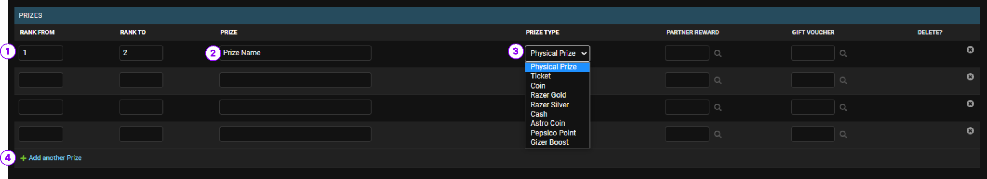

1. Enter Ranking range to reward prize. (If only one rank, set i.e Rank From = 1, Rank to = 1.
2. Enter the name of the prize Name
3. Select the type of prize

Depending on prize type, the Prize name content will differ, i.e Tickets, Only put numeric value.

1. Add a new entry field

**Prize format based on Prize type table**

| **Prize Type** | **Format** | **Sample** |
| --- | --- | --- |
| Physical Prize | Numeric & Text | Iphone 13pro |
| Ticket | Numeric only | 999 |
| Coins | Numeric only | 999 |
| Razer Gold | Numeric only | 999 |
| Razer Silver | Numeric only | 999 |
| Cash | Numeric only | 999 |
| Astro Coin | Numeric only | 999 |
| Pepsico Points | Numeric only | 999 |
| Gizer Boost | Numeric only | 999 |

#### Automatic Prize

Automatic Prize Pool enables players to get rewards based on the number of participants joined using our own internal calculation & algorithms.  
  
Automatic Prize Pool enables players to get rewards based on the number of participants joined using our own internal calculation & algorithms.

To set up this, simply choose Automatic under Prize Calculation Type in Prize Customization Configuration.

The details of Prize Payout   
Max Players: 500  
% of Prize Money Distributed to Players from Total Buy In = 60%

% of Number of Players Rewards = 25% of players Joined.

Note: The Automatic Prize Pool only works with a maximum number of 500 participants.

**Setting Up**

To set up this, simply choose Automatic under Prize Calculation Type in Prize Customization Configuration after configuring the basic config for manual prize tournament

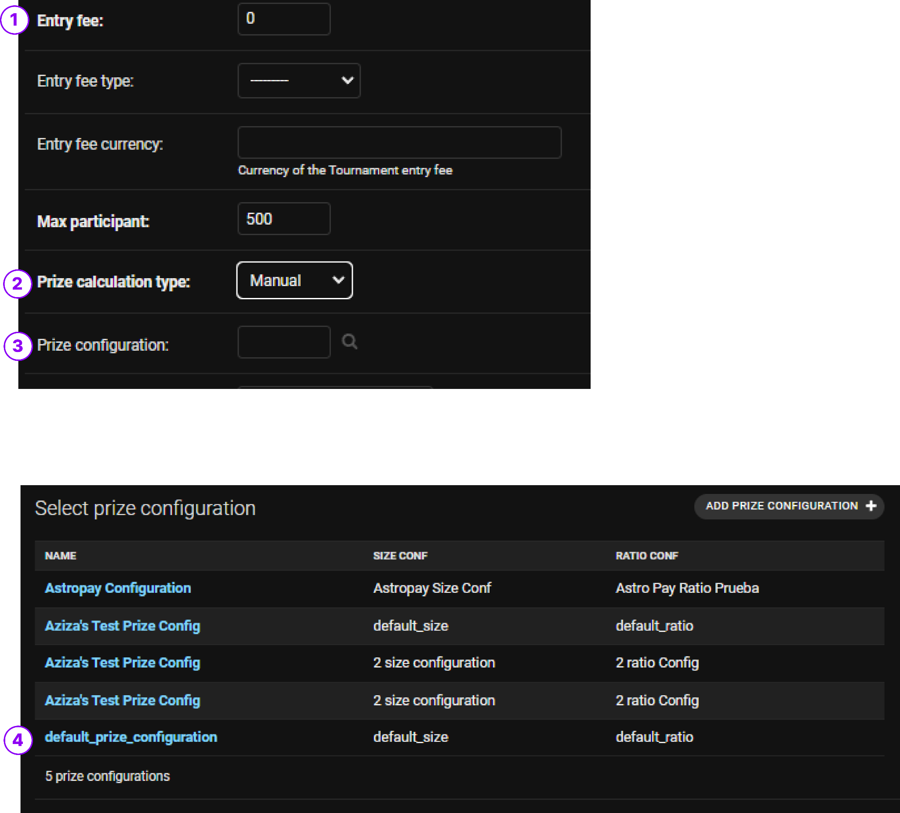

1. Enter the entry fees
2. Set Prize Calculation > Automatic
3. Select Prize Configuration > default_prize_configuration
4. Default_prize_configuration settings:  
     
   Max Players: 500  
   % of Prize Money Distributed to Players from Total Buy In = 50%

% of Number of Players Rewards = 25% of players Joined.

***Note:*** *The Automatic Prize Pool only works with a maximum number of 500 participants.*

#### Dynamic Prize

Dynamic prize is more like an enhanced version of Manual/Fixed Prize Distribution   
Prizes are unlocked in different tiers as more players join the tournament.

Dynamic prize helps attract users more than Fixed Prize Distribution as the prize pool increases as more players join which helps contribute to the growth of our NSM as well.

To test out what works best you can use the following link:

http://games.goama.io.s3-website-ap-southeast-1.amazonaws.com/dtpc/index.html

Setting Up Dynamic, all you need to do is to select the Prize Calculation Type under Prize Customization menu in the Tournament settings.

*We set up the prizes, quantities & value of each prize. We provide entry fee and profit margin we want to keep.   
  
Algorithm calculates how many users are needed in order to unlock a prize. More users means players are able to unlock new tier prizes.*  
This means there is no loss in profit as the cost of rewards are always covered.   
  
We set up the prizes, quantities & value of each prize. We provide entry fee and profit margin we want to keep.

Algorithm calculates how many users are needed in order to unlock a prize. More users means players are able to unlock new tier prizes.

**Setting Up**

After configuring the basic config for manual prize tournament continue the following:

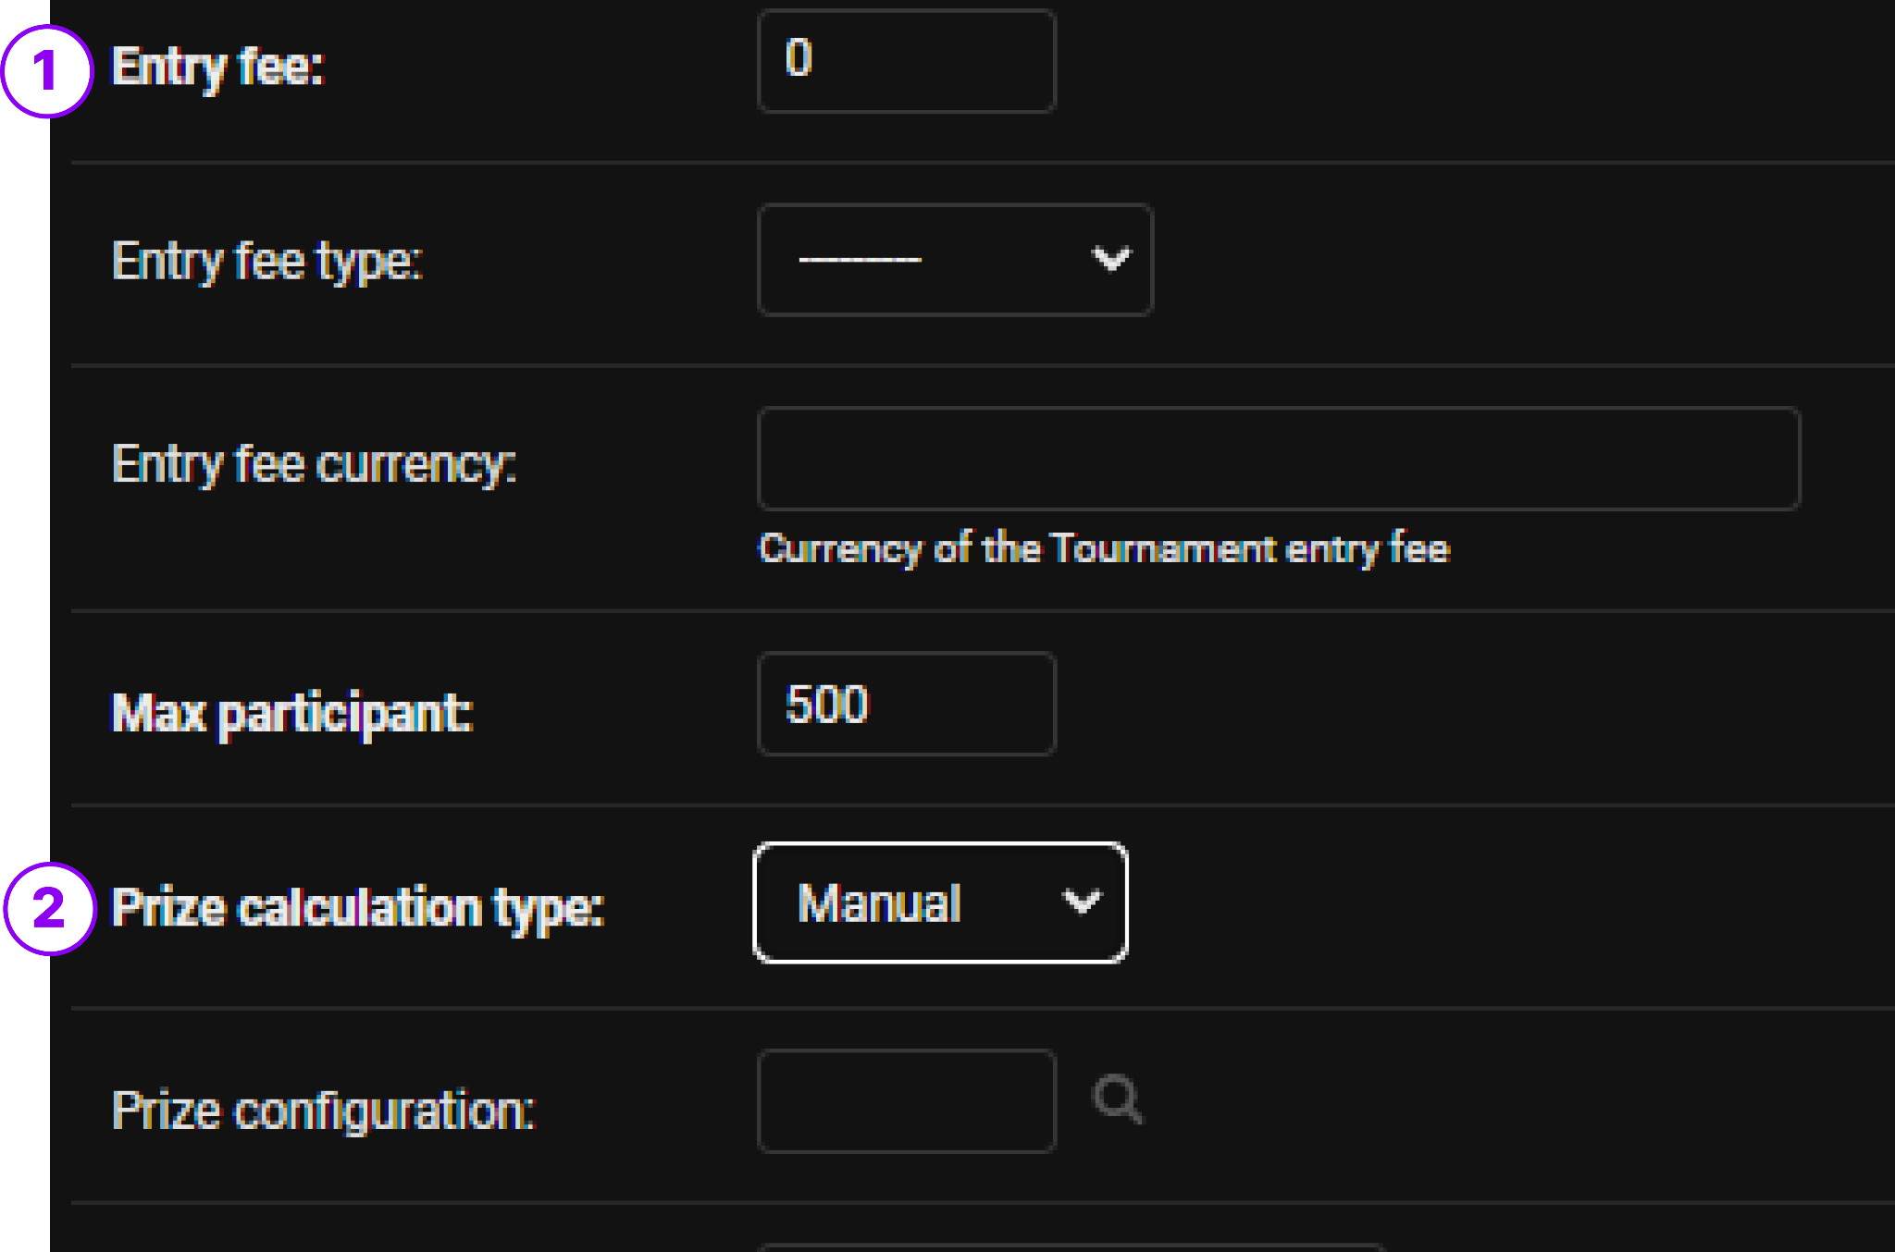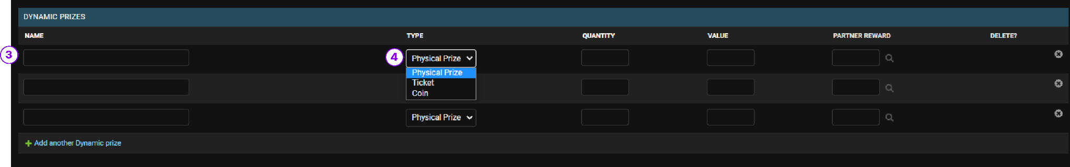

1. Enter the entry fees
2. Select the prize calculation type > Dynamic
3. Enter the name of the prize,
4. Select the prize type.

| **Prize Type** | **Format** | **Sample** |
| --- | --- | --- |
| Physical Prize | Numeric & Text | Iphone 13pro |
| Ticket | Numeric only | 999 |
| Coins | Numeric only | 999 |

## Try Based Tournaments

### User Journey

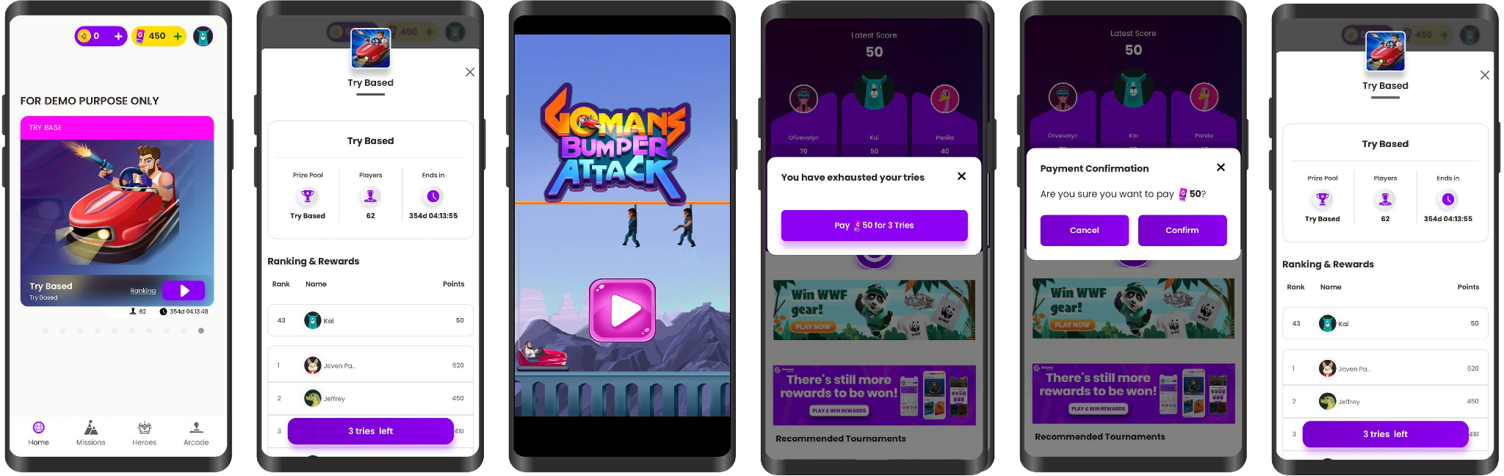

### Configuration & Setups

**Log into your Django Portal > Under Tournaments Section > Click on Tournaments > Add Tournament**

After configuring the basic config for manual prize tournament,

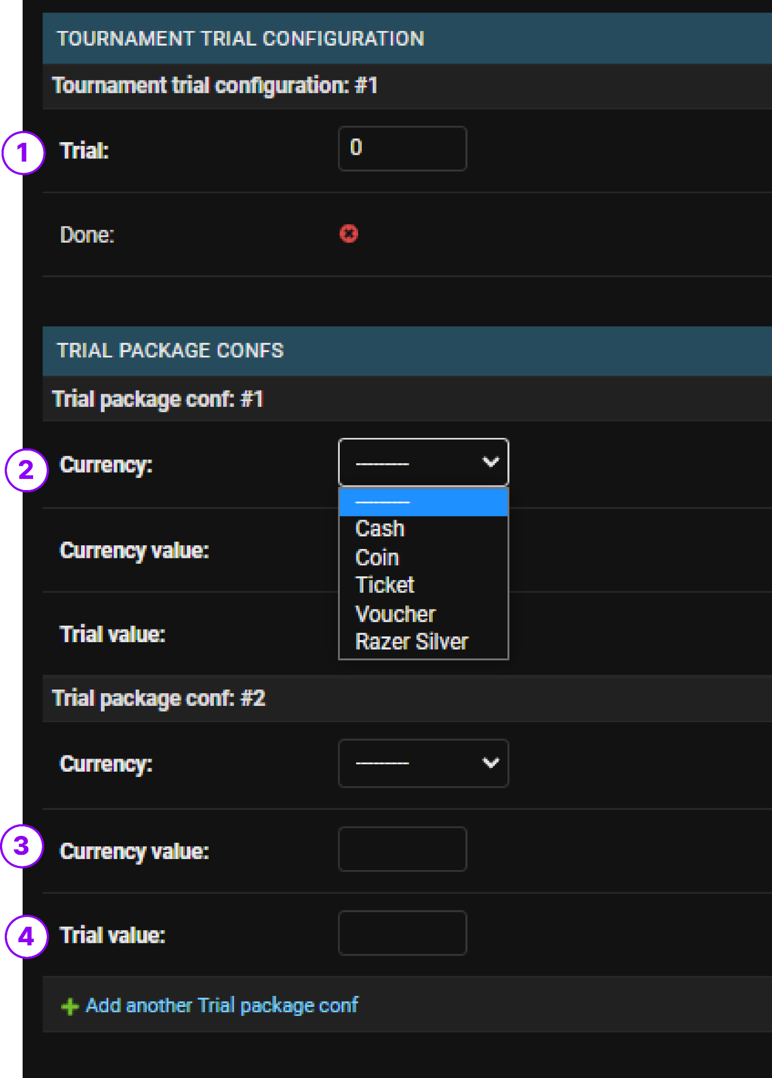

1. Enter the amount of times user will be allowed to try the game for free
2. Enter the type of currency that user will need to pay with after tries are used up
3. Enter the amount of value that user will need to pay for this particular pack
4. Enter the amount of tries user will be awarded once paid for this pack

**Sample:** Currency = Tickets, Currency Value = 50, Trial Value = 2 means this package will deduct 50 tickets to give users 2 tries

## Exclusive Tournaments

### User Journey

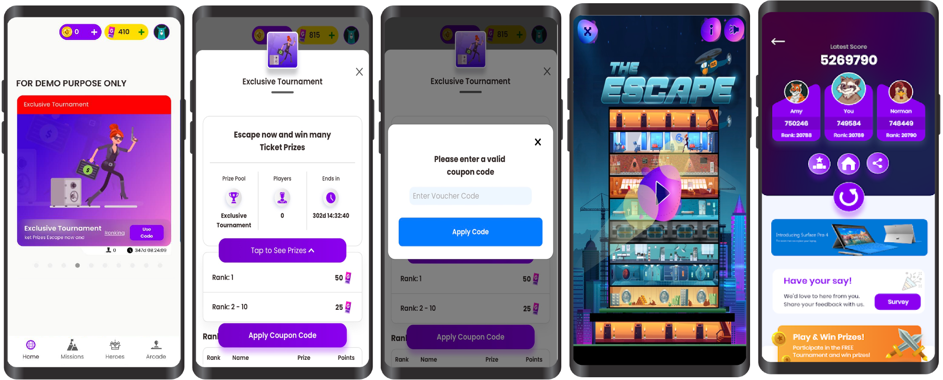

### Configuration & Setups

**Log into your Django Portal > Under Tournaments Section > Click on Tournaments > Add Tournament**

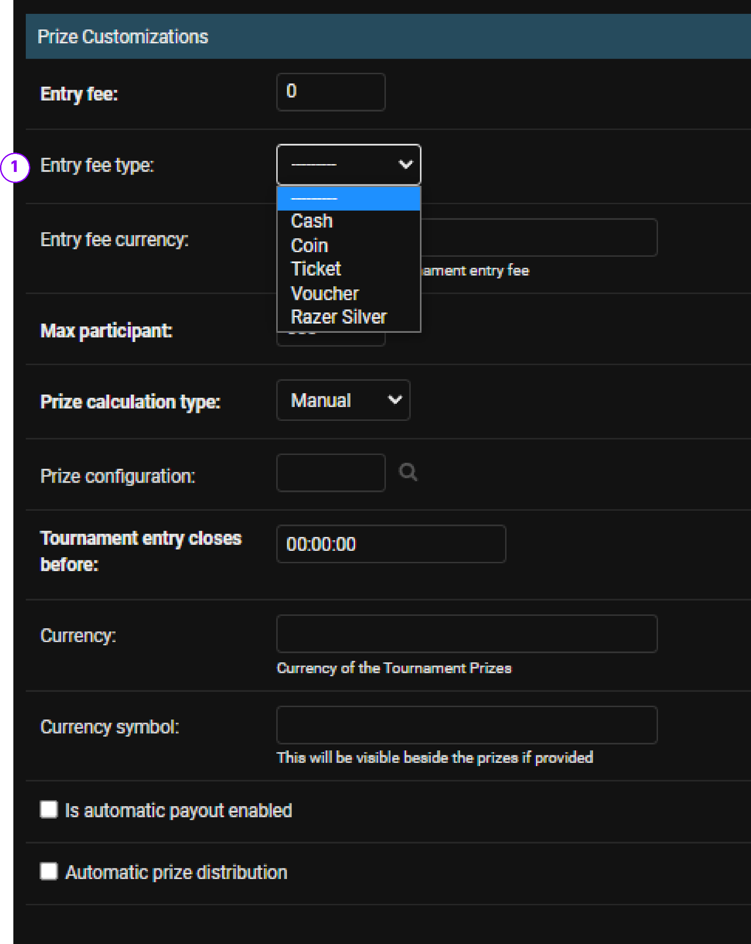

**SETTING UP VOUCHER CODES FOR EXCLUSIVE TOURNAMENT**

**Log into your Django Portal > Under Payments › Vouchers › Add voucher**

1. Set entry fee type > Voucher

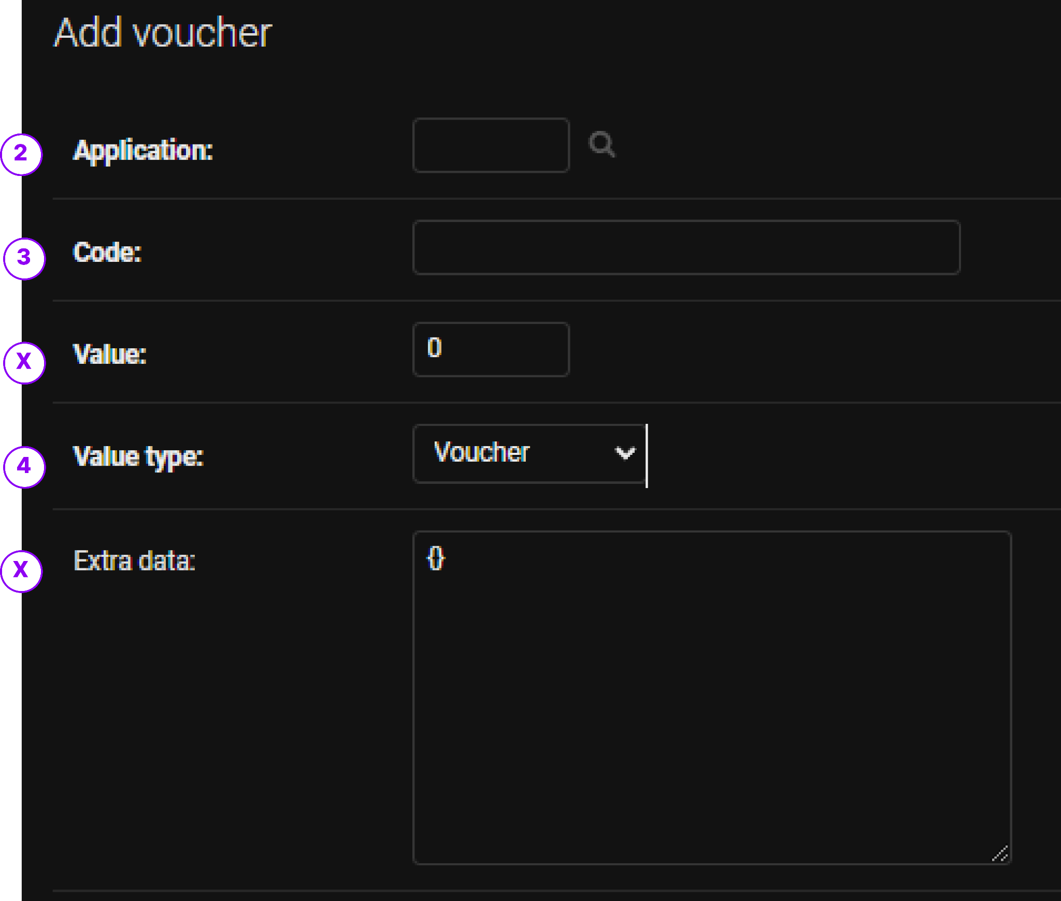

1. Select your desired application
2. Enter your random code
3. Select voucher type > Voucher

**SETTING UP MULTIPLE VOUCHER CODES**

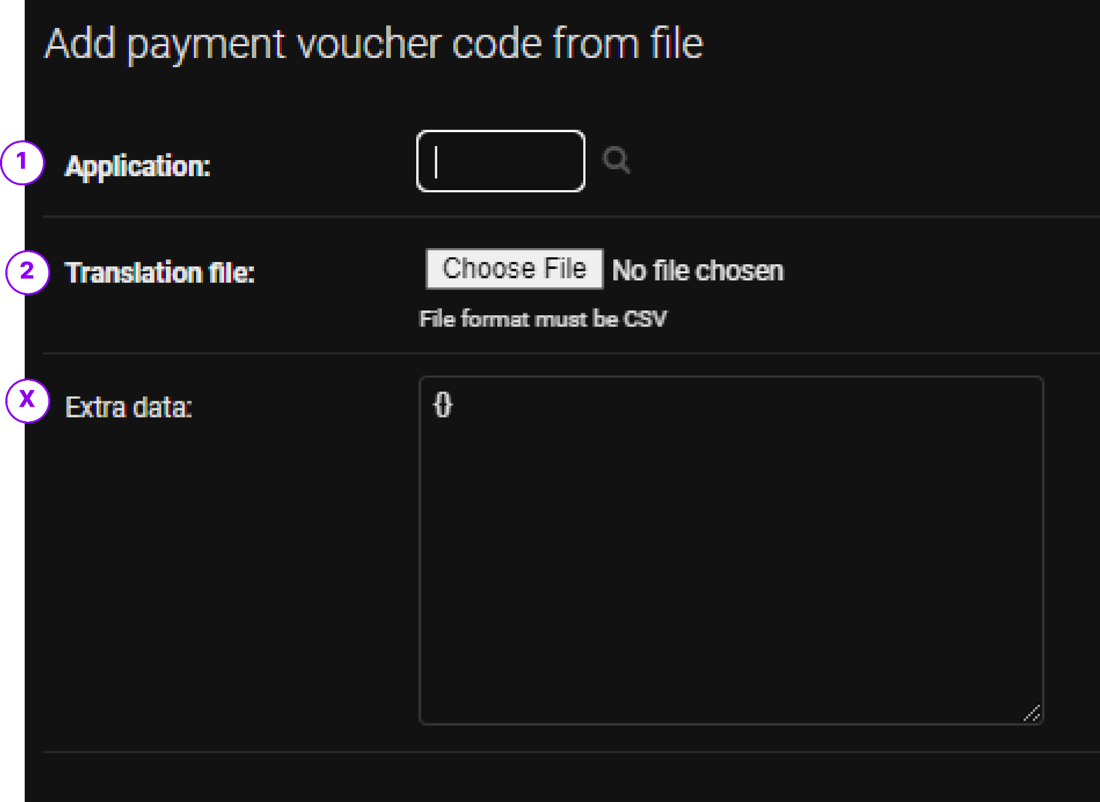

1. Select your desired application
2. Upload a .csv file excel sheet with the following Table columns

| Voucher_Code | Voucher_Value_Type | Voucher_Value |
| --- | --- | --- |
| Sample1234 | coin | 100 |
| Code456 | voucher | 100 |

## Other Tournament Setups

# Battle & Player vs. Player

## Free Battles

### User Journey

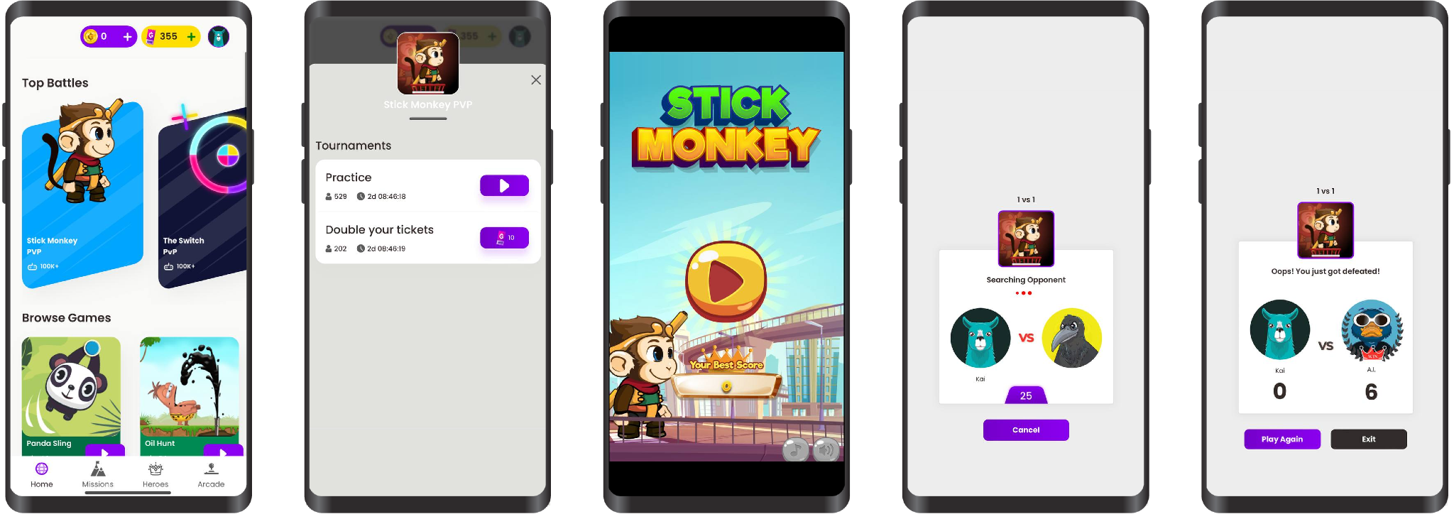

### Configuration & Setups

The setting up process for PvP is the same as other regular tournaments with a difference of choosing games & Tournament Type.

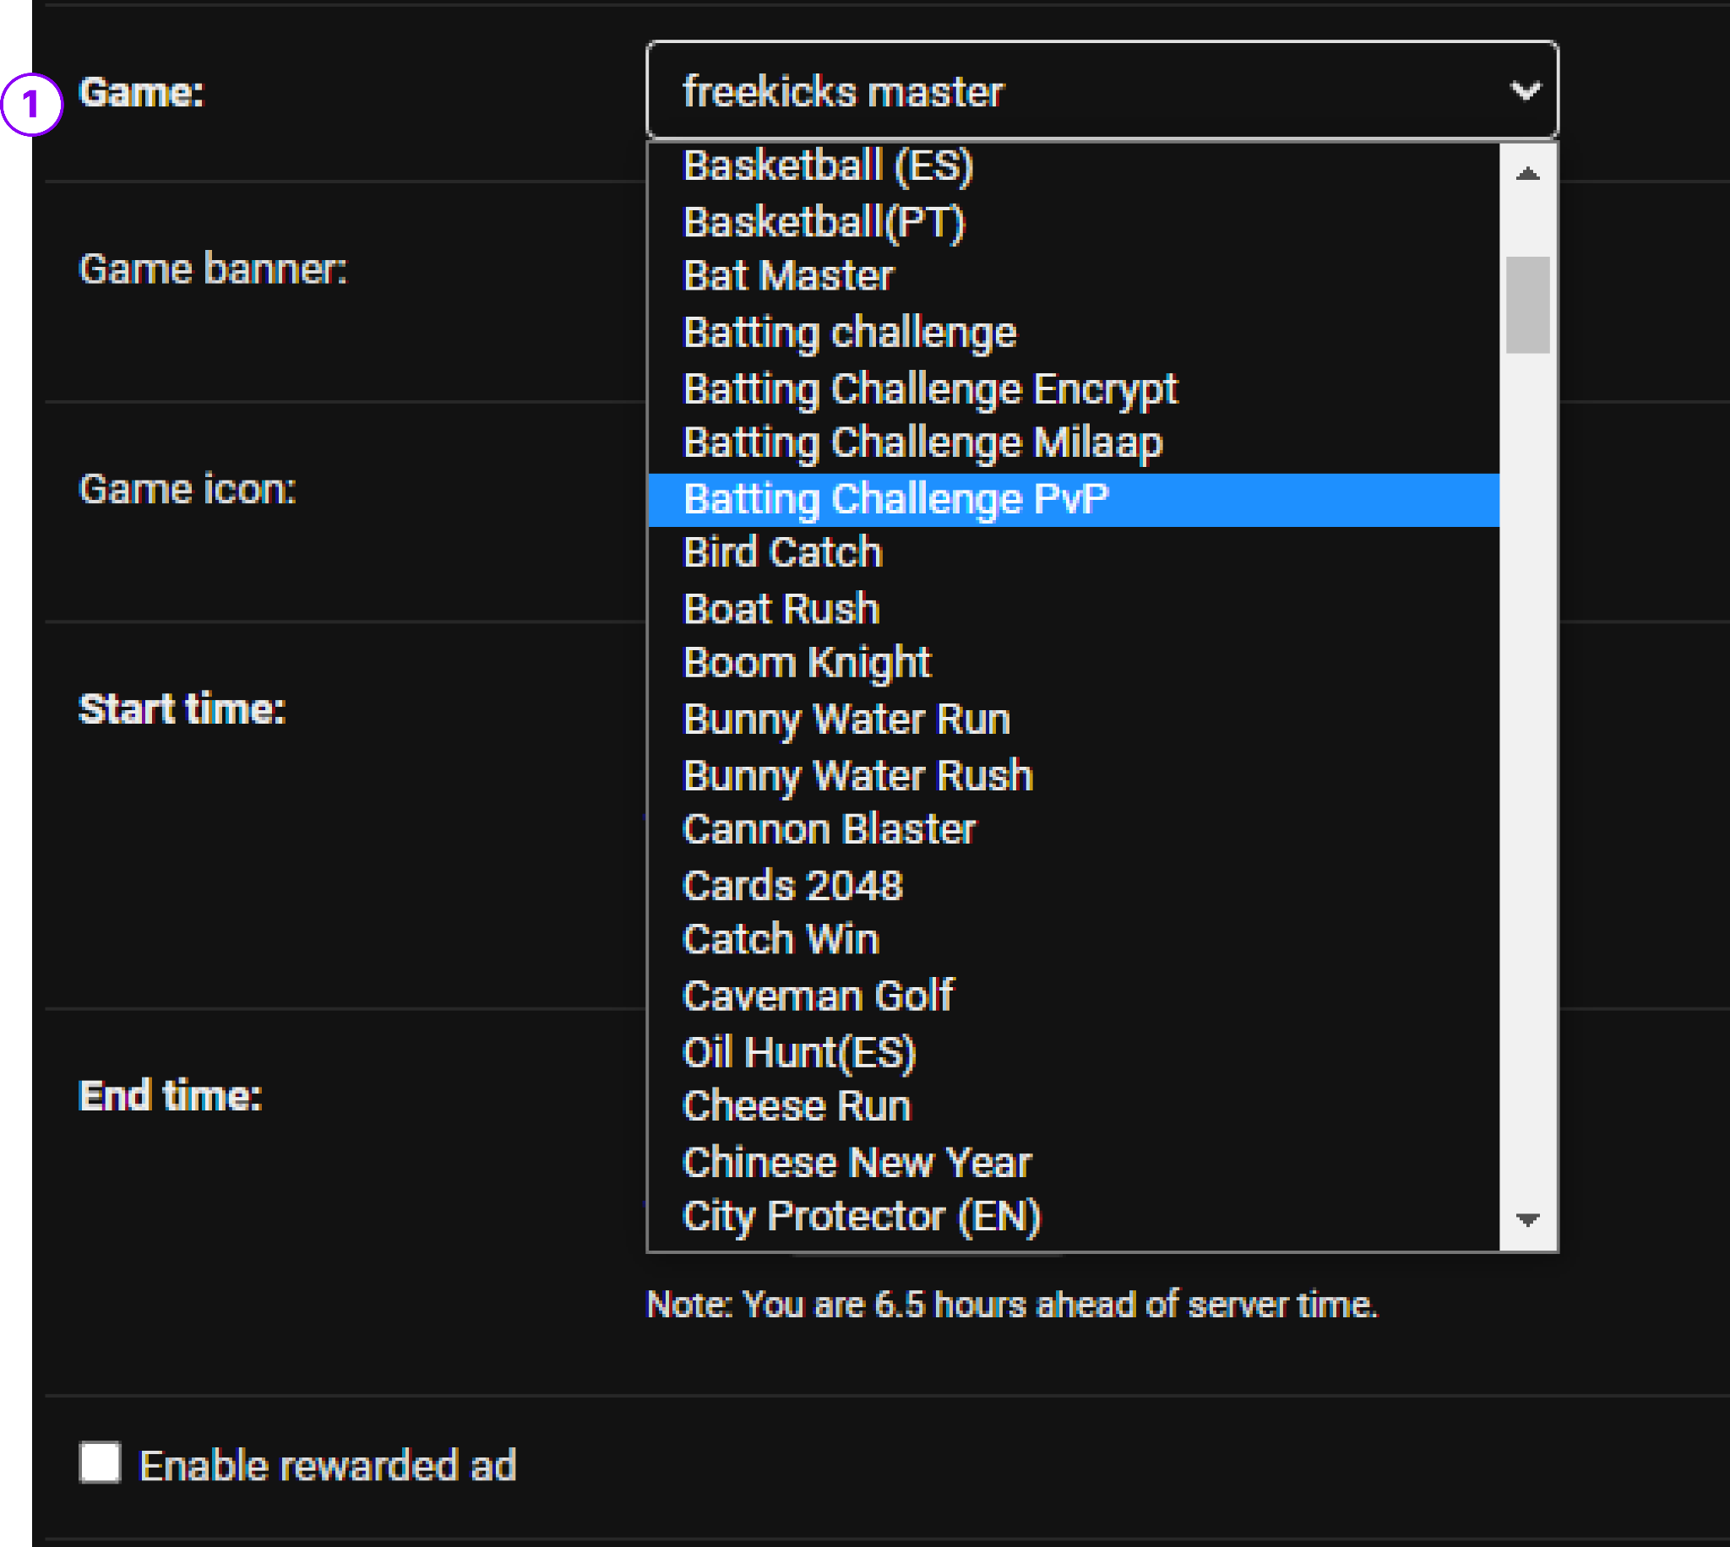

1. The game chosen must be a PvP labeled game.

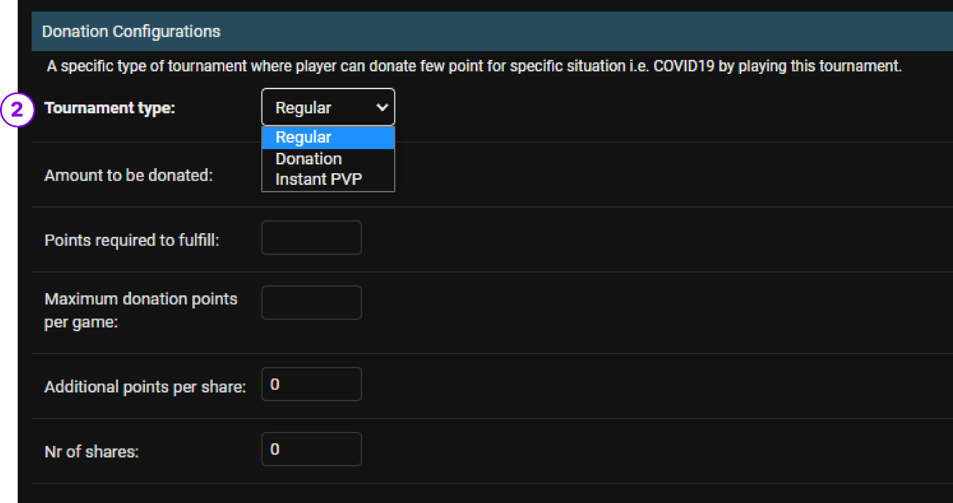

1. You must change the tournament type to Instant PvP from the above settings.

## Paid Battles

Similar to regular tournaments, PvP Battle Tournaments also can be made into paid PvP Battles.   
  
However, unlike regular tournaments for PvP setups, it is not required to input Prize Configuration or Prizes settings.

### User Journey

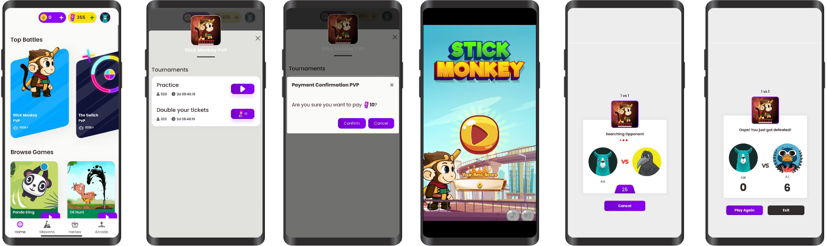

### Configuration & Setups

The setting up process for PvP is the same as other regular tournaments with a difference of choosing games & Tournament Type.



1. The game chosen must be a PvP labeled game.



1. You must change the tournament type to Instant PvP from the above settings.

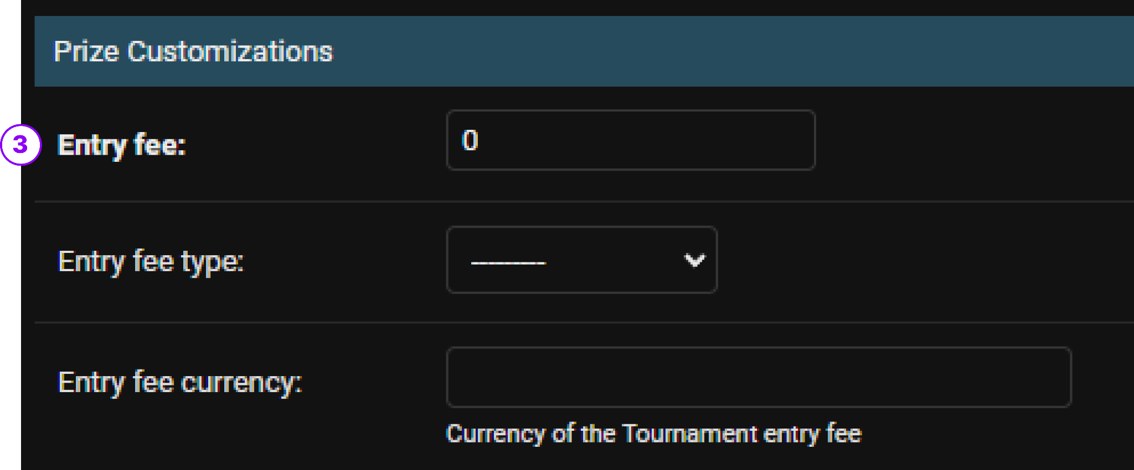

1. To enable a Paid Pvp, simply enter the entry fee.

NOTE: Paid PvP works differently to Paid Tournaments.   
  
Since the game is 1 v 1,   
  
By Default, if a tournament is set PvP & entry fees is input.   
  
Winners will get the amount of entry fees input & the same entry fee type.   
Entry fee type can also be configured to enable users to participate in tickets, coins or other currencies.

There are 2 key types of Paid Tournaments

###### 

# Add-On Features & Configurations

**Login to Django Panel > Under Tournaments Section > click on Tournaments**

## Highlight Banner

Highlight Banner is used to emphasize a tournament with extra info provided to the player to attract the tournament.

### User Journey

### 

### Configuration & Setups

During the Tournament setup, Highlight banner can be set up simply by inputting the preferred text and selecting the colour of banner.

1. Input preferred Text
2. Select preferred Banner Color

## Tickets, Coins & Redemption

## What are Tickets ?

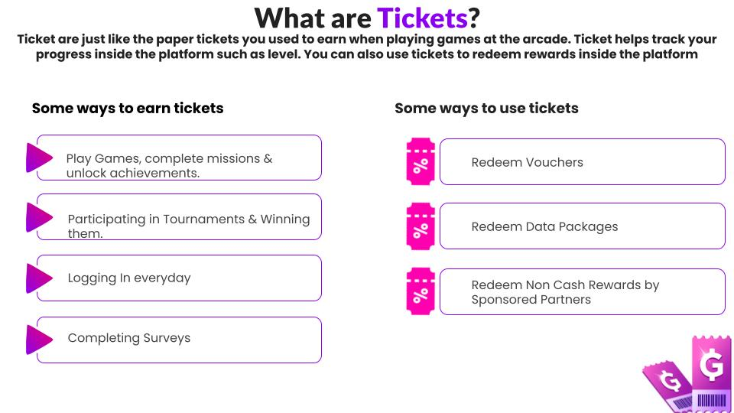

### User Journey

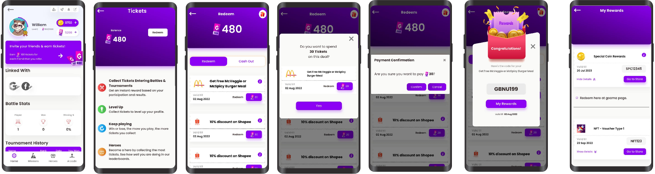

### Configuration & Setups

**Login to Django Panel > Under Tournaments Section > click on Application**  
  
Select your desired existing Application or create a new application.

Then scroll down to Application Settings & check Enable User Journey setting.  
   
This will enable the Tickets System in your selected Application.  
  
You must also choose a country from select countries in the Enable Journey.  
  
You may upload the User Journey Image with the Ticket Icon Assets file.

Then Save.

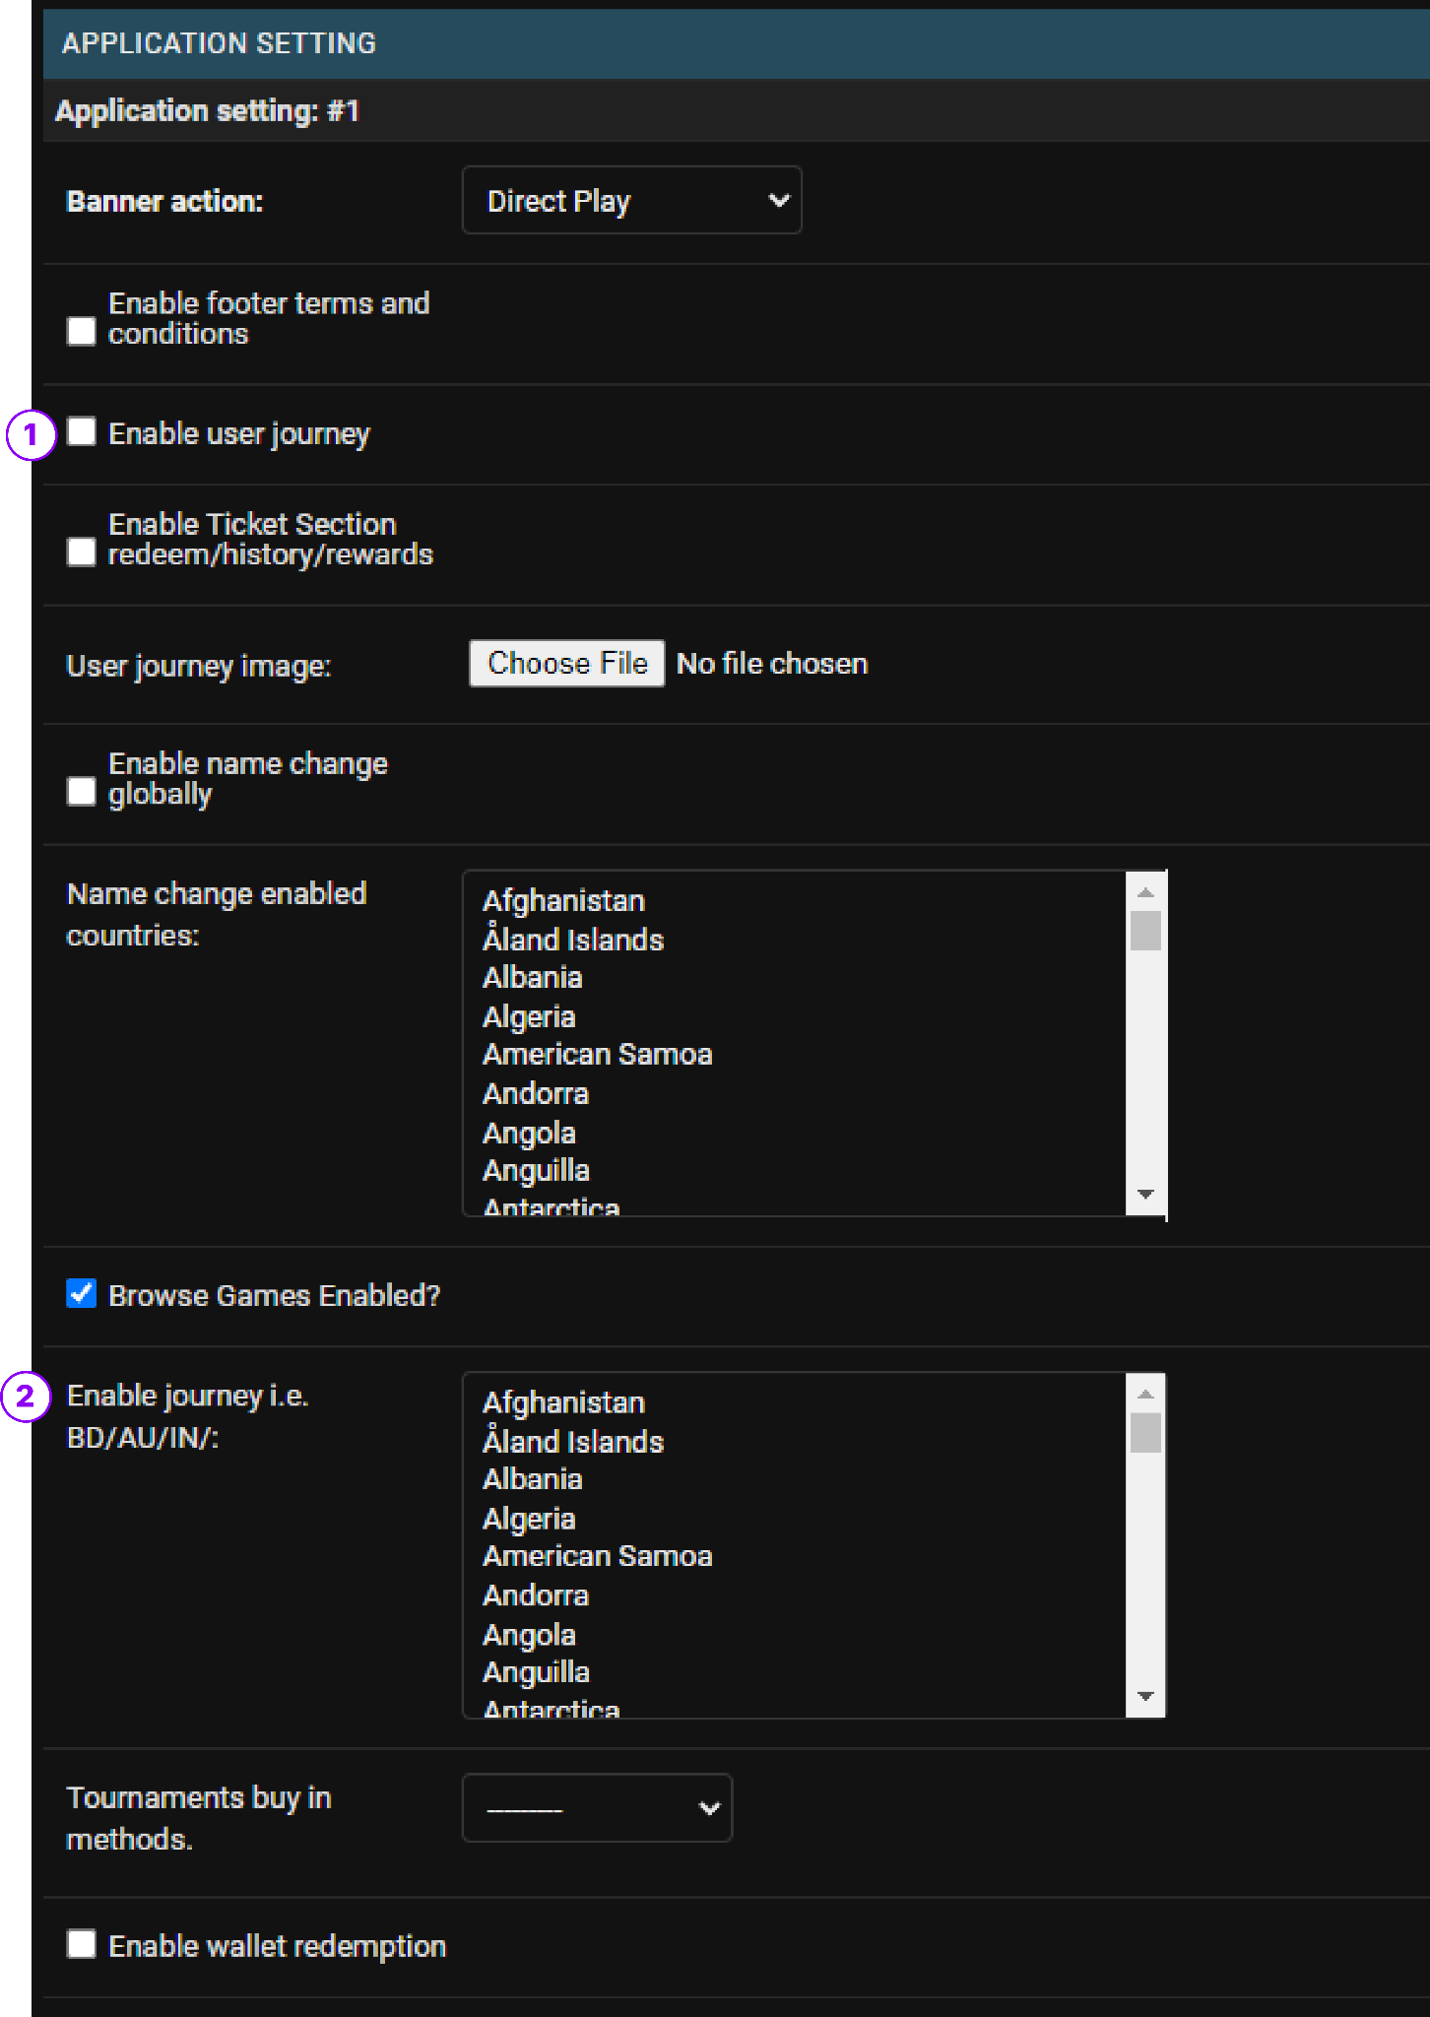

1. Enable User Journey
2. Select the Country you want to enable this feature.

## 

## Ticket/Coin Redemption

Redemption allow players to redeem vouchers & coupons using the Tickets that they have accumulated through game play and winnings

### User Journey

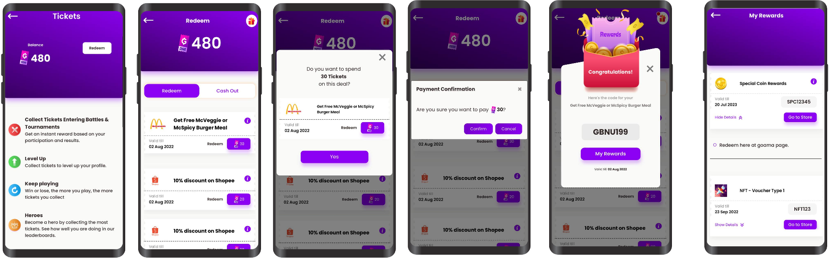

### Configurations & Setups

**Login to Django Panel > Under Tournaments Section > click on Application**

To enable Redemption

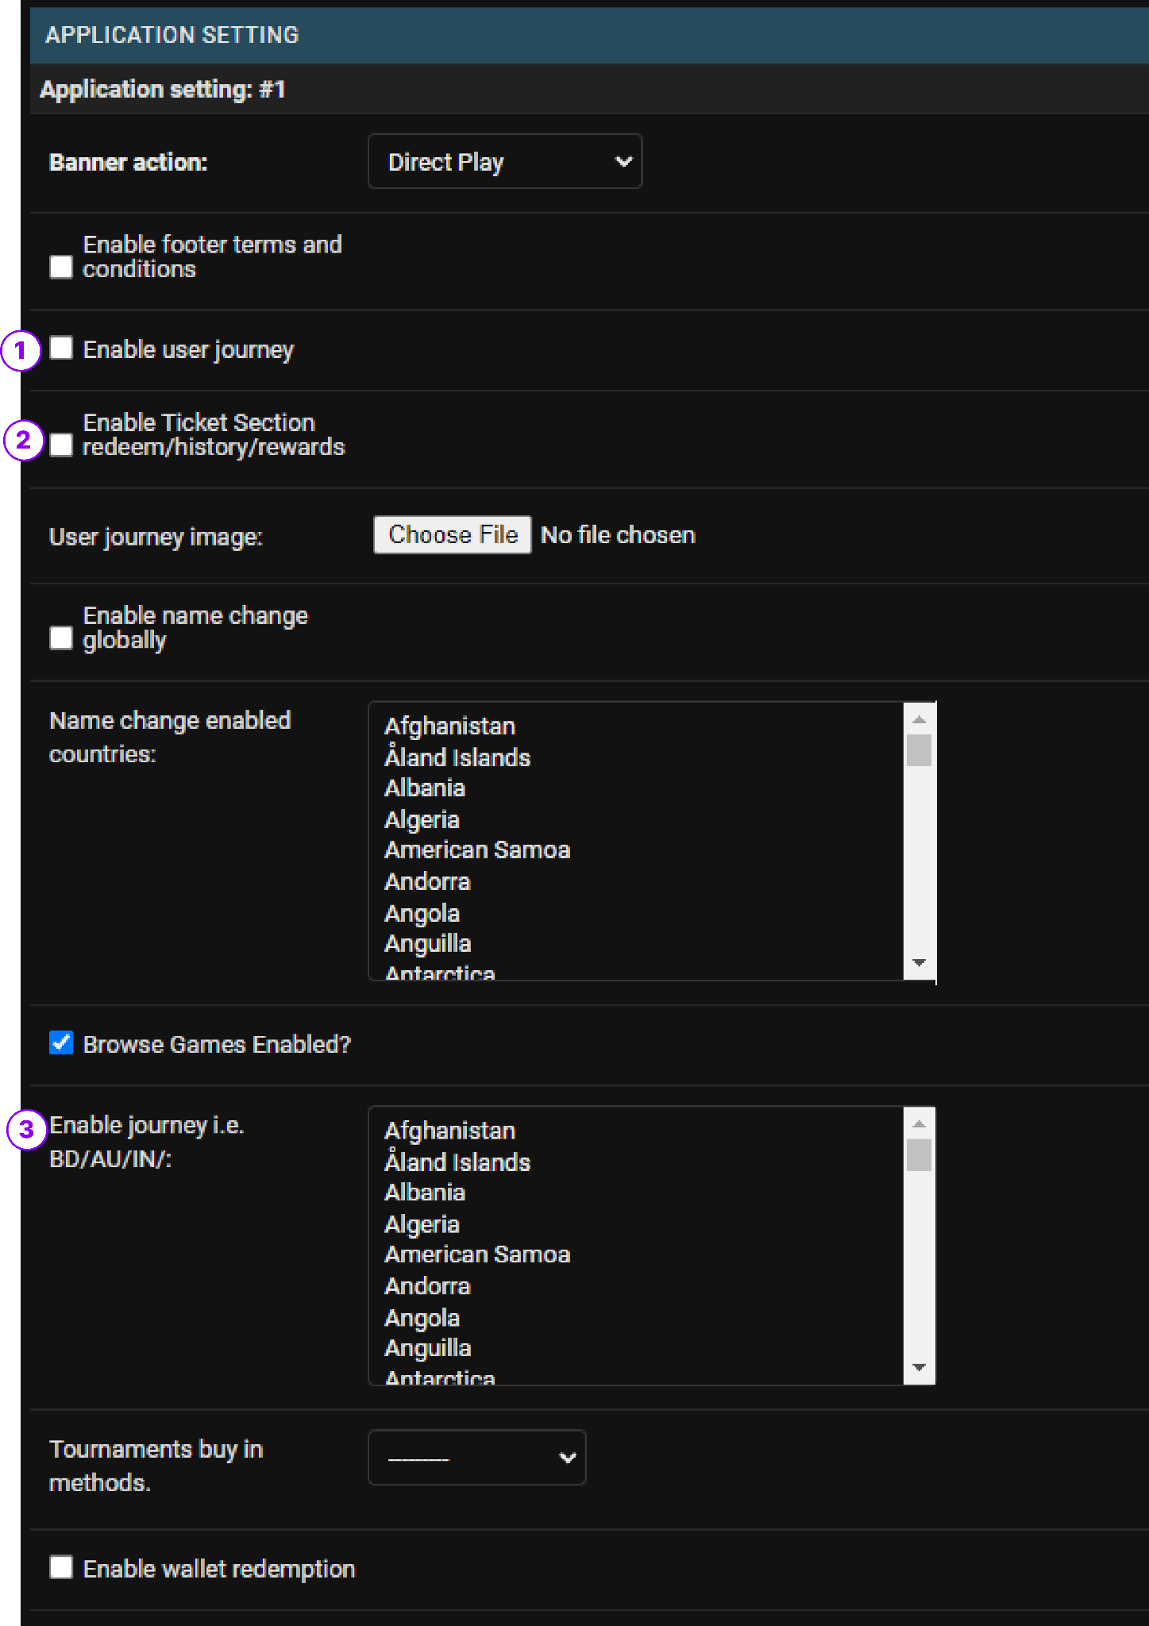

1. User Journey must already be enabled
2. Enable Ticket Section
3. Select the country you want this feature to be enabled.

## Vouchers for Redemption

### Configurations & Setups

**Login to Django Panel > Under Prizes > Rewards**

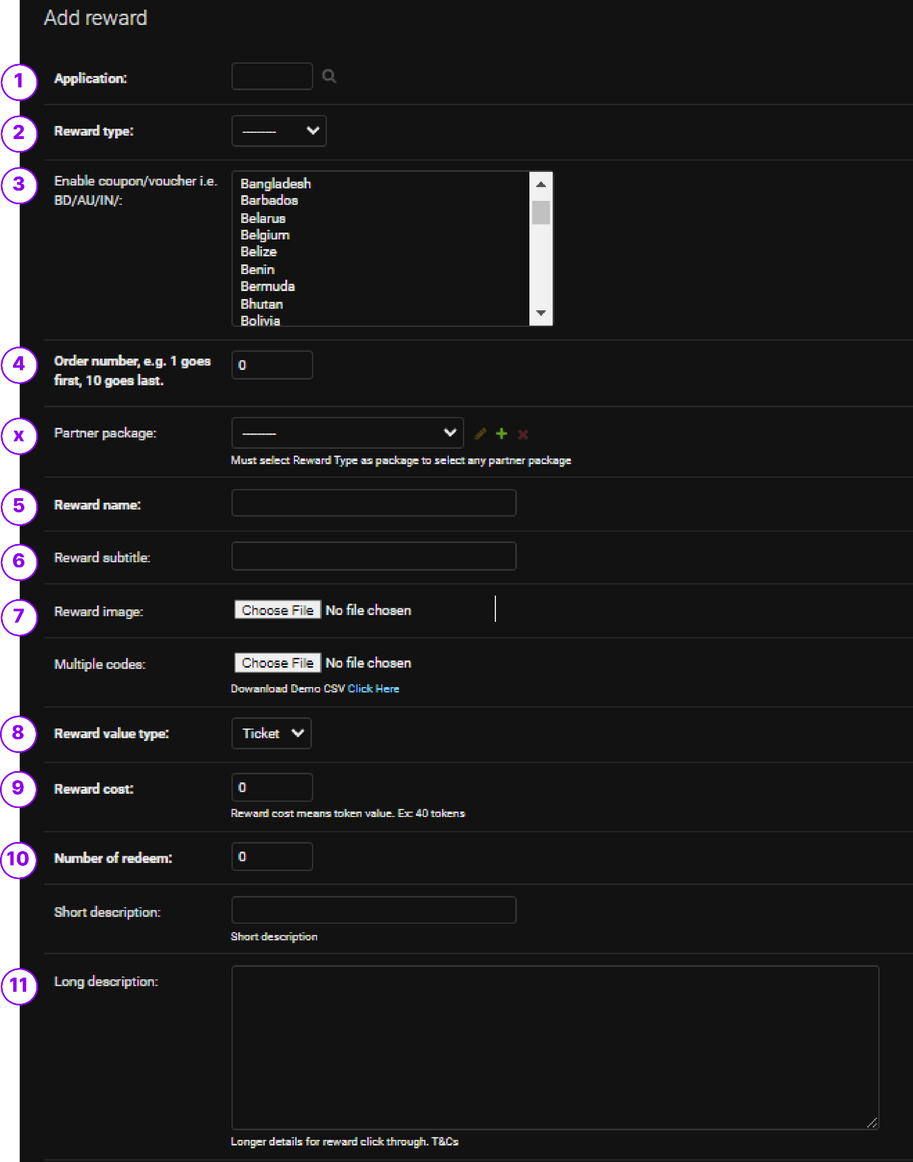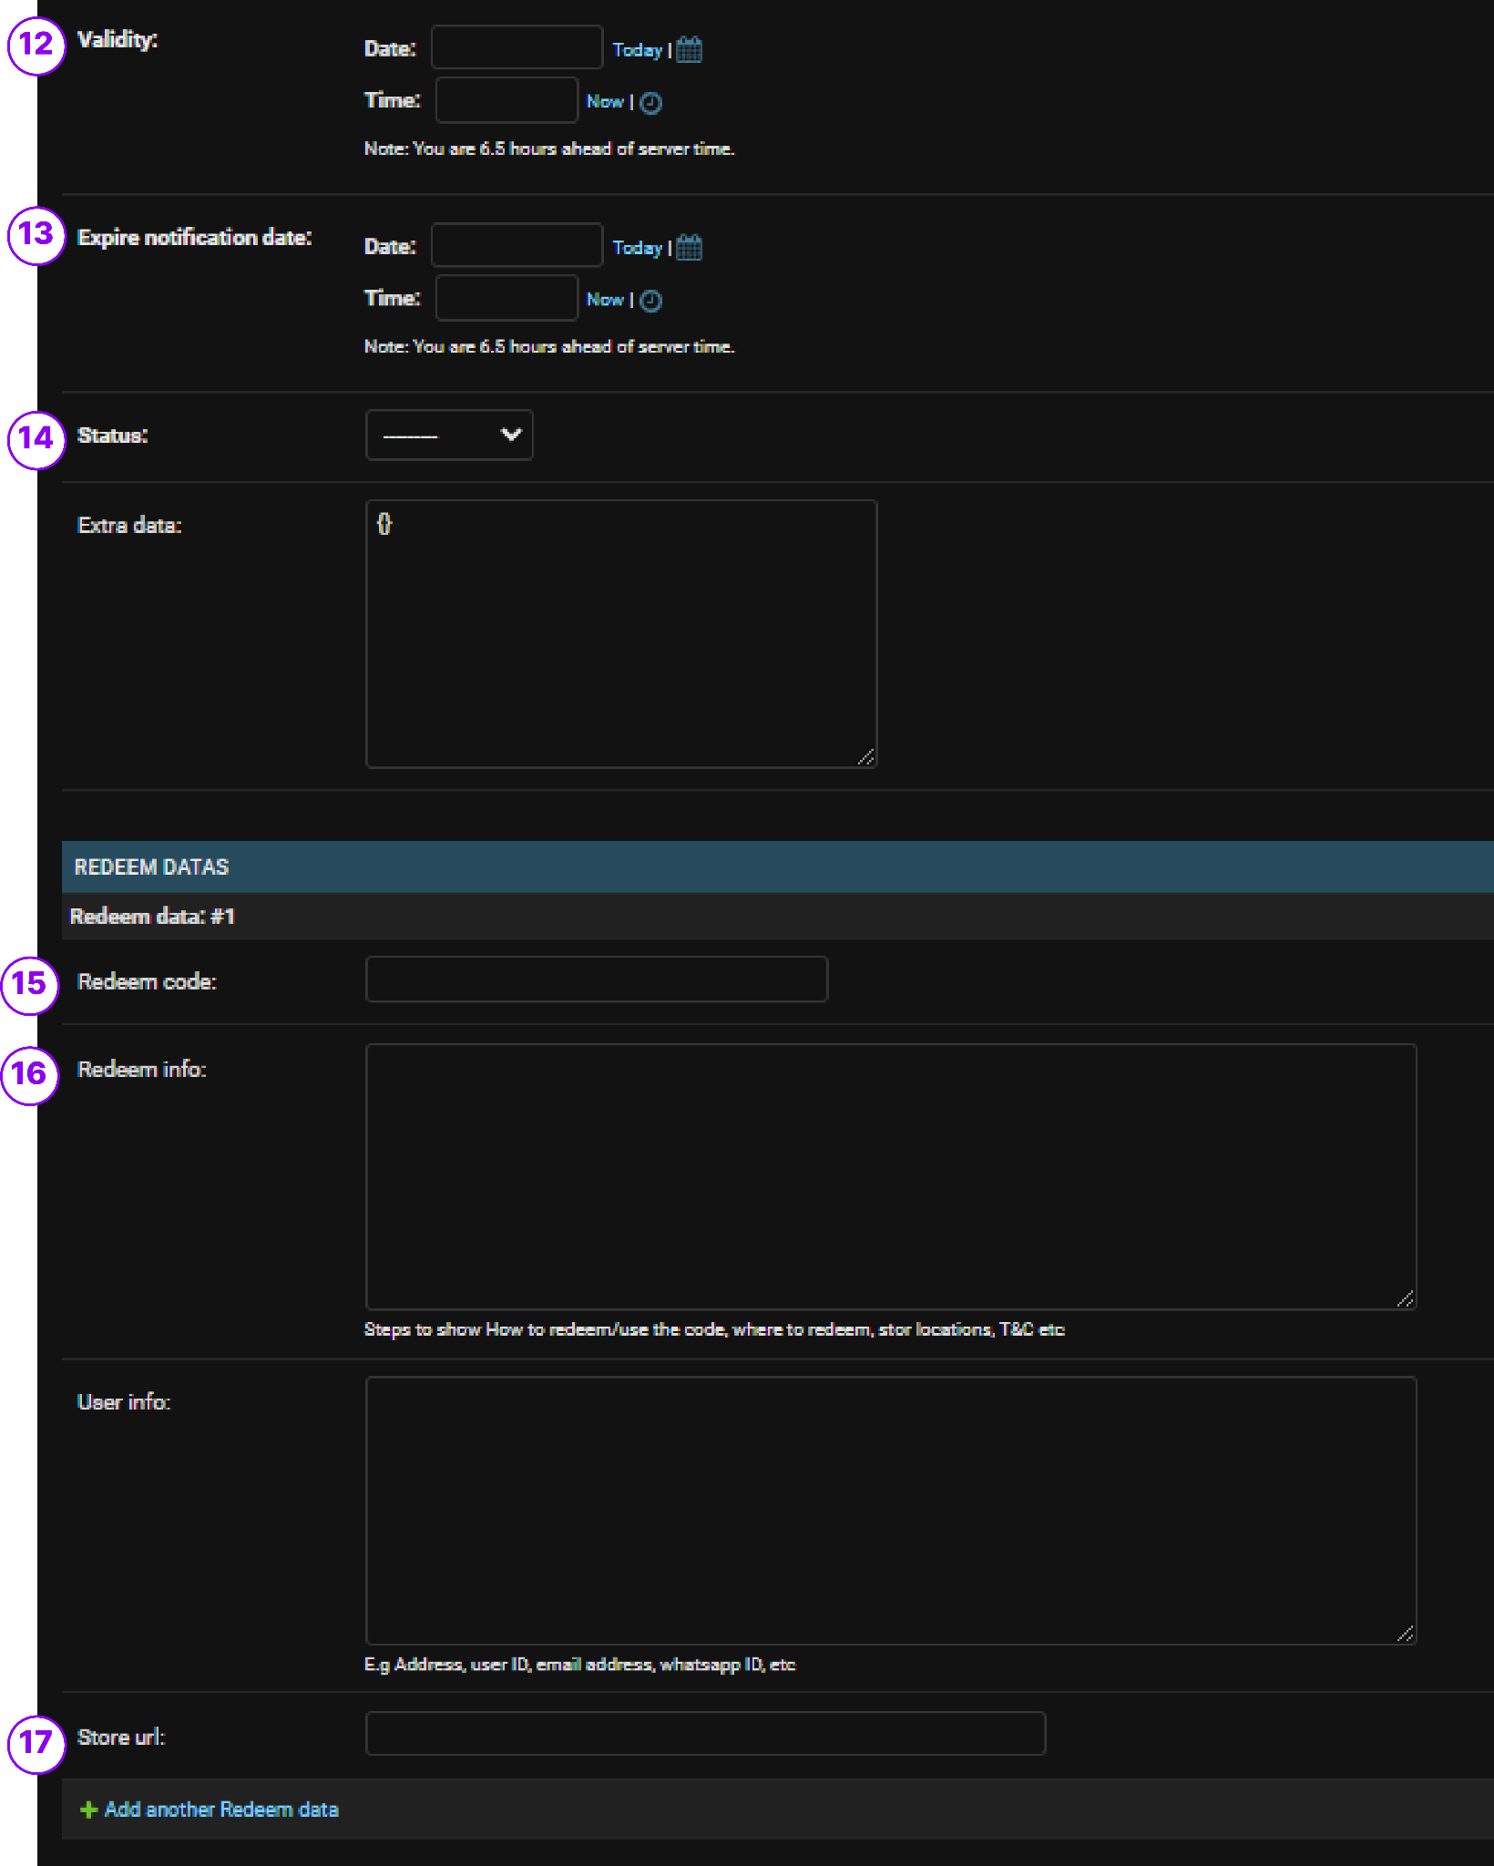

1. Select your preferred Application
2. Select Reward Type: Voucher
3. Select your preferred Country to enable this Voucher
4. Optional: can be customized to select the order of arrangement this voucher will appear in the redemption center
5. Name of the Reward
6. Sub-info of the Reward
7. If the voucher has an image, can be uploaded here.
8. The type of currency that can be used to redeem the reward
9. Enter the amount that will be deducted to redeem the reward
10. Number of times this reward will be allowed to be redeemed by all players.
11. Long Description of the reward that will appear upon redemption
12. Time range on when this reward will appear in the redemption center.
13. Date range of alert that will notify the player if the reward is soon to expire.
14. Set status to Publish to enable the reward in the Redemption Center..
15. Unique code that must be entered to redeem this reward.
16. Extra info section to guide player on how to redeem this reward
17. If a store is available enter the URL of the link to redirect play to this specific page for redeeming.  
      
    NOTE: No. of Redemption = total amount of redeems per voucher per person first come first serve

## Missions

### User Journey

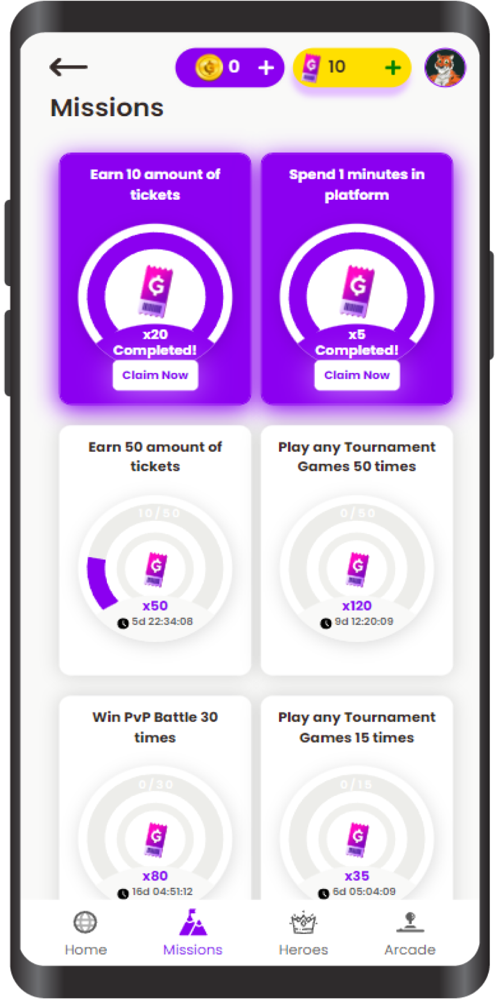

### Configurations & Setups

**Login to Django Panel > Under Mission Offer > click on Add Mission Offer**

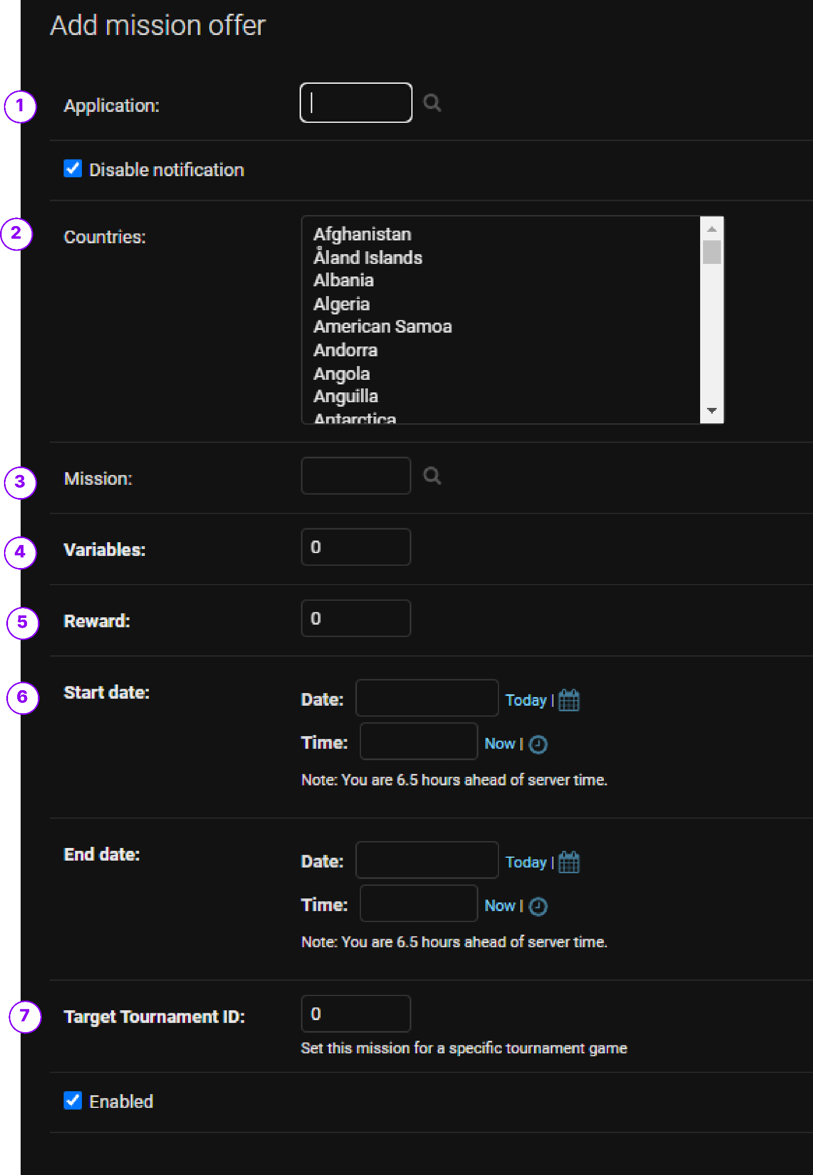

1. Select your preferred Application where you would like to enable this mission
2. Select your preferred country where you would like to enable this mission
3. Select type of mission
4. Enter the variable of the mission where you will assign how many times a player need to complete a criteria to complete mission
5. Amount of reward to be given to the player upon completion of mission
6. Select reward type (In updated Admin panel, which is missing in the above given screenshot)
7. Date range of when this mission will be available to the player
8. If the mission is specific to a game or tournament, you need to enter the Tournament ID, else leave as default.

### List of Missions Events Available

1. Score {duration}s in {game}
2. Score {score} in {game}
3. Share To {x} amount of friends
4. Join {x} amount of tournaments
5. Earn {x} amount of tickets
6. Earn {x} amount of coins
7. Win PvP Battle {x} times
8. Play any Tournament Games {x} times

## Banners & CTA

### Welcome Banner

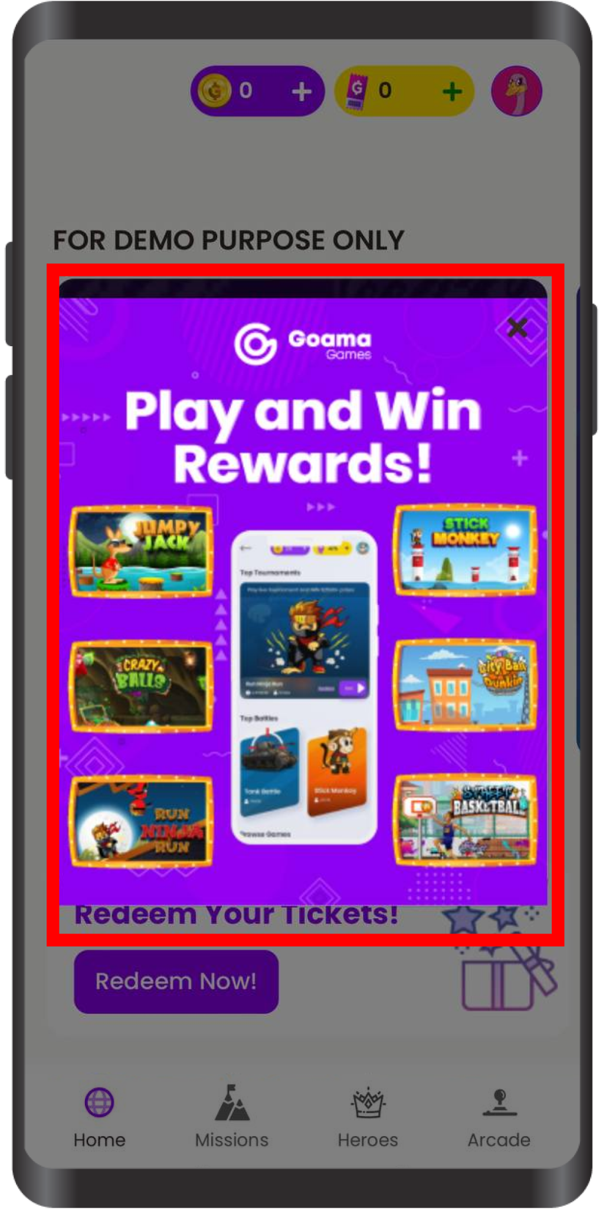

### Configurations & Setups

**Login to Django Panel > Users › Message templates › Add message template**

### You need to set up a message template that is configuration for Banner first

1. Upload Banner Image file
2. Title of the Welcome Banner
3. Internal Title for future references
4. Text body of the Welcome Banner
5. Choose color of the text body
6. Choose background color of the Welcome Banner
7. Button Name
8. Color of the CTA Button
9. Color of the CTA text
10. Paste the redirect CTA link in this field
11. Type of popup (please type as per example provided)

**Login to Django Panel > Home › Campaign › Campaigns › Add campaign**

Once message template has been set up. You can start configuring the frequency and nature of how the welcome Banner will appear in the Campaigns settings.

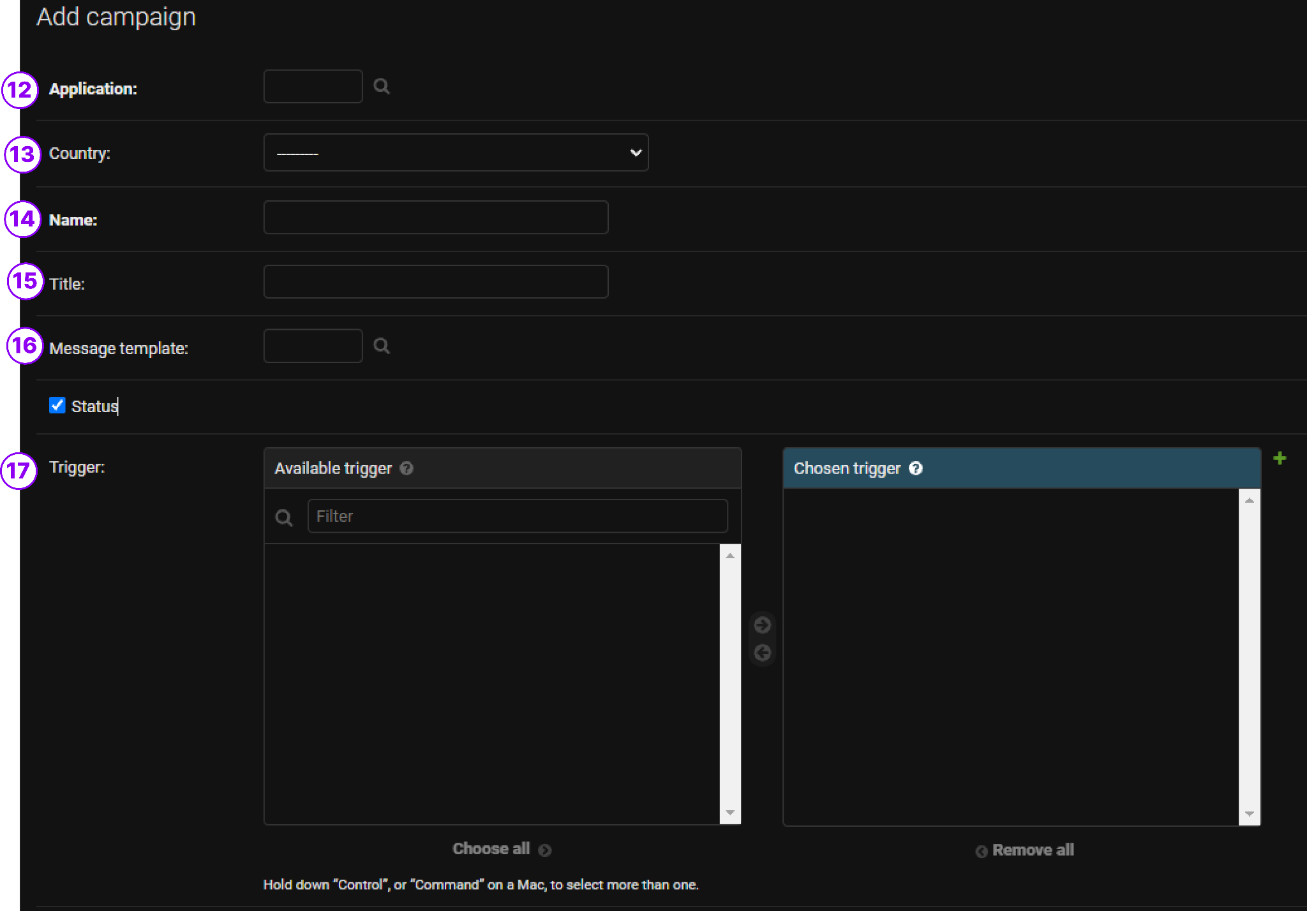

1. Select your preferred application to apply this campaign
2. Select your preferred country to apply this campaign
3. Name of the Campaign
4. Title for internal reference
5. Select message template that has been pre-created
6. Select the type of trigger that will make the banner appear

Depending on the type of trigger configured, the welcome banner can be made to appear in different ways:

* Specific Day - Welcome Banner will appear to everyone on this specific day
* Consecutive Users - Welcome Banner will appear to users that login consecutively after x days.
* Returning Users - Welcome Banner will appear to users that returns after x amount of days

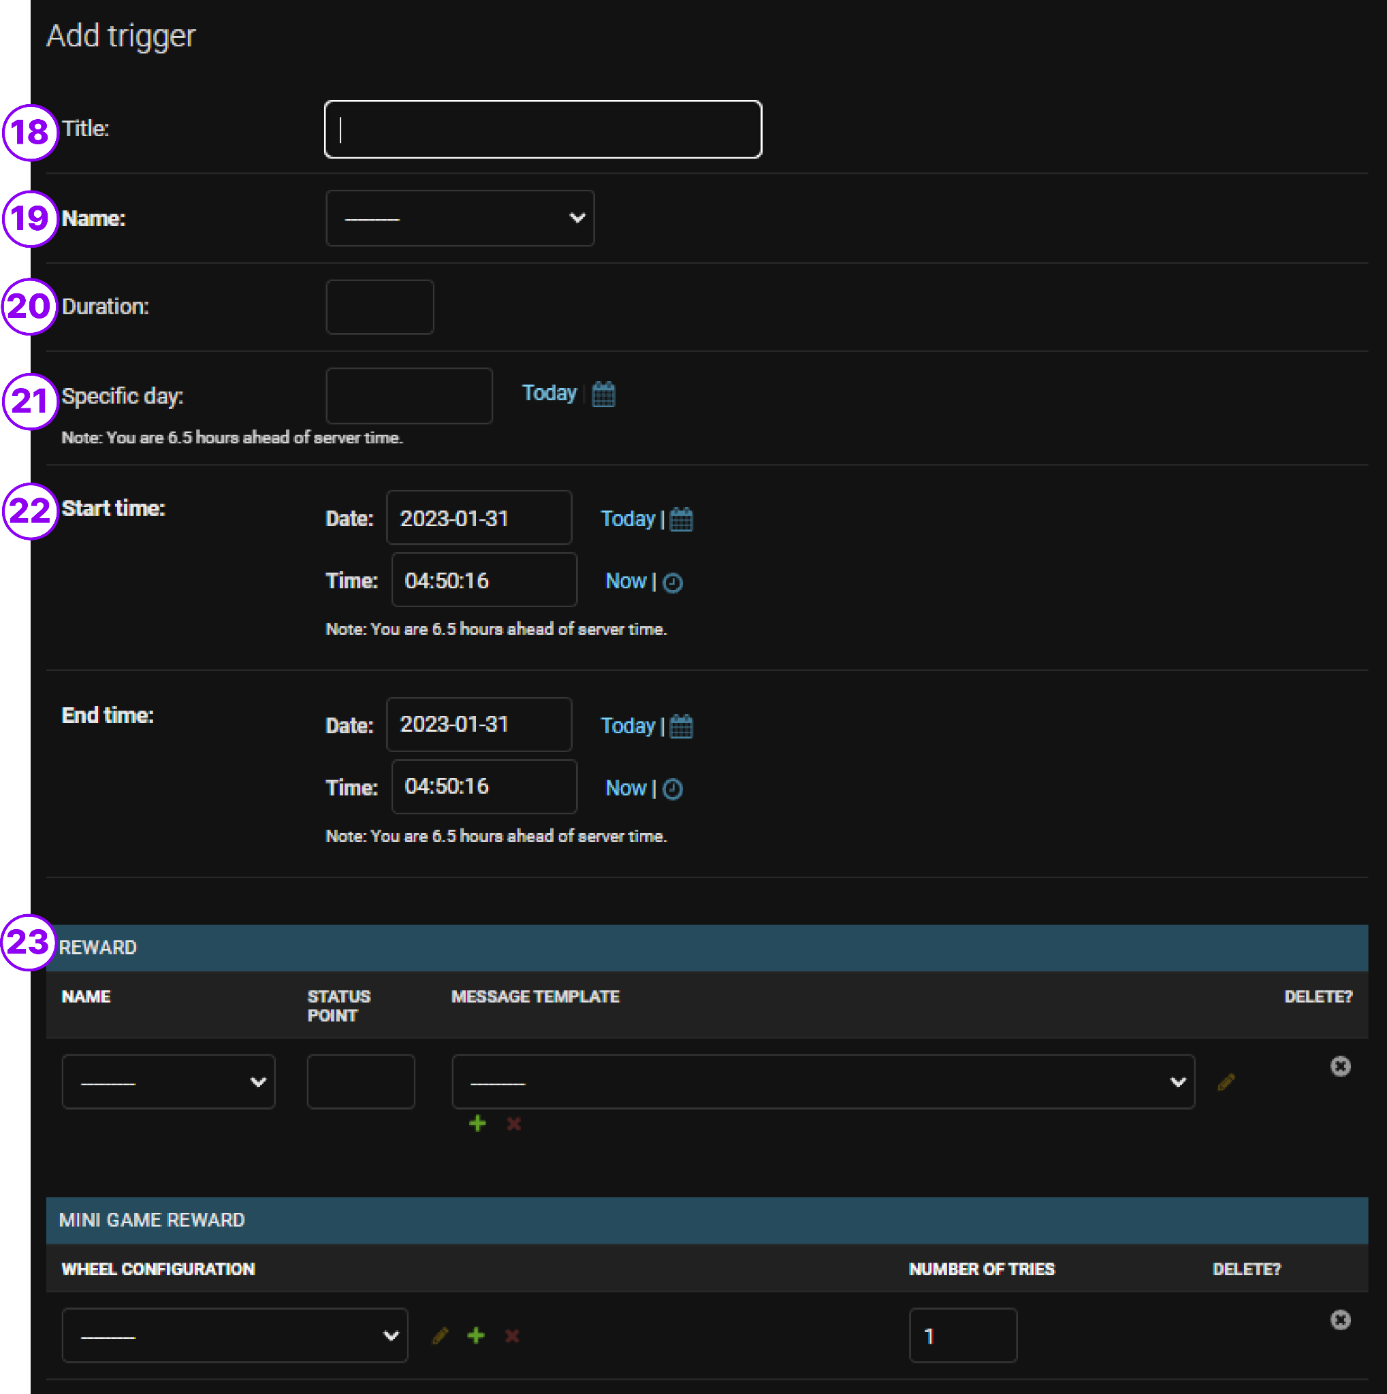

1. Title of the Trigger
2. Select the type of trigger you wish to apply
3. Duration input logics change upon type of trigger   
   Leave blank for Specific Day Trigger   
   Consecutive = Login consecutive for (Duration) day   
   Returning = Return after (Duration) amount of days
4. Select date for specific trigger
5. Duration of the Campaign / Trigger to apply to the Welcome Banner
6. Select either status points or message
   1. Status Points - to reward players with tickets, amount configured under Status Point field
   2. Message - leave status point blank and choose message template.

### Home Screen Banner & End Screen Banner

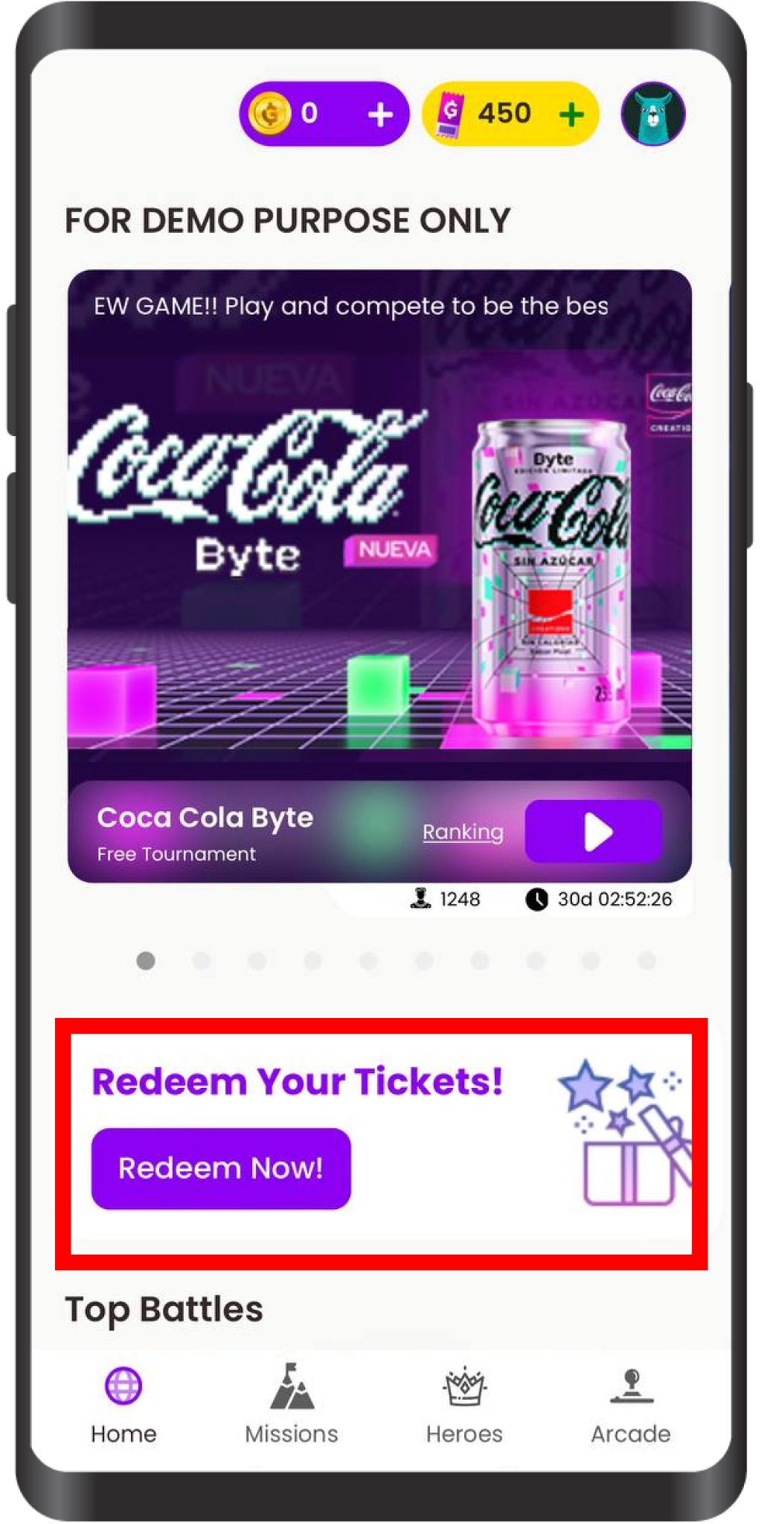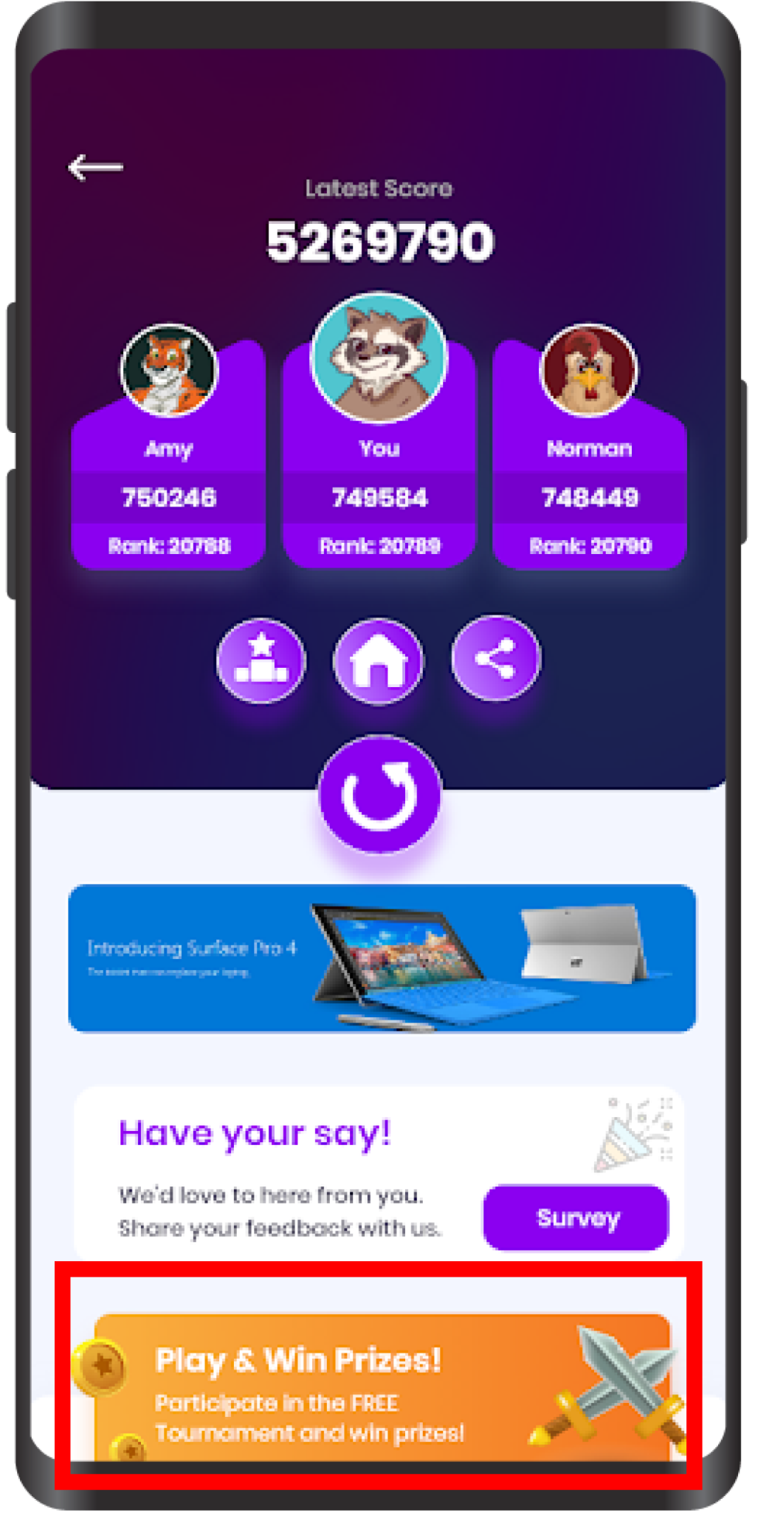

### Configurations & Setups

**Login to Django Panel > Under Tournaments Section > click on Application**

### 

1. Choose the background color of the banner
2. Chosse the placement of the CTA (Homepage or Endscreen Page)
3. Title of the CTA Banner
4. Colour of the Title
5. Sub-body text of the CTA Banner
6. Color of the Sub Body Text
7. Whole banner image can be uploaded via image file
8. Name of the Button of the CTA ( Can be left blank)
9. Color of the CTA Button
10. Type of Link:   
    Iframe - opens seamlessly as part of the platform  
    New Window - opens an external window

Pop-Up - open as a pop up

1. Input the link for cta to redirect upon click
2. Add for another CTA Banner

### Winner Notification Events

List of Notification Logics & Events

* When a friend uses the refer a friend code (User Referral Config)
* If the user gets a Spin the wheel
* If there is new missions added on the mission panel
* When new tournaments are added
* When the tournament is about to end,(roughly around 20 -30 mins)
* Notify the users when the tournament ends, with ranks and prizes

### Configurations & Setups

###### Winner Notification Setups

To Set Up Winner Notification, a participant ID is required from the report.

To get the report, go to Django > Tournament > Get Tournament Report and enter the Tournament ID to download the report file.

Get the list of all the winner participant IDs.

The tournament must be first archived before enabling Winner Notification.

**To enable Winner Notification, go to Django > Tournament > Voucher**

Create New Voucher from Files

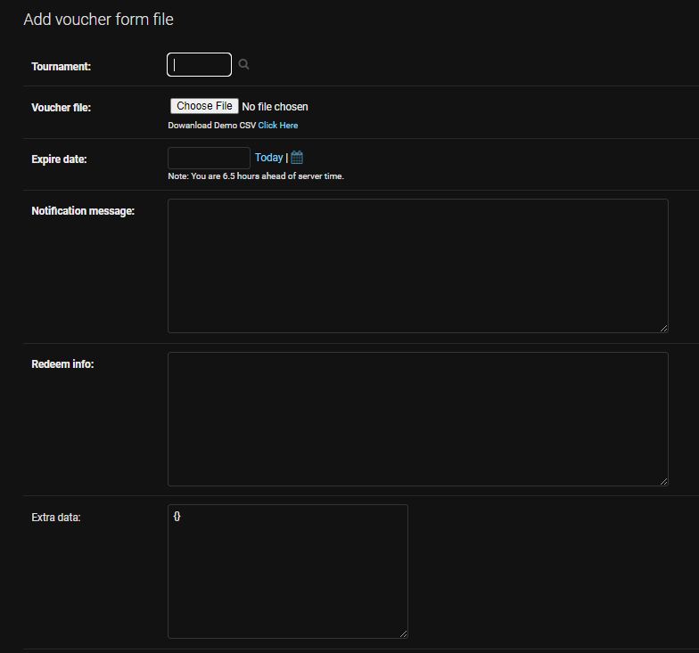

Input Tournament ID

Click on “Click Here” to download the CSV files.

Open the downloaded CSV files.

Replace the Participant ID in the 2nd Column (Winner List according to correct rank)

You can also replace a custom Voucher Code or provided by partner in the 3rd Column

You can also enter a redirection URL link in the 4th column.

Expired Date - choose the date, the message for expire date will be displayed.

**Notification Message Template** - Congratulations. You Won a {game_name} voucher from Goama Games. Here's your prize voucher code: {voucher_code}. Use bKash on your next transaction with {app_name}. Valid until {expire_date}

Text inside {} variable constants. Change the messages but keep the {} variable constant.

## Daily Login Bonus

Daily login is a feature to encourage to login every day and in doing so received some form of reward.

### User Journey

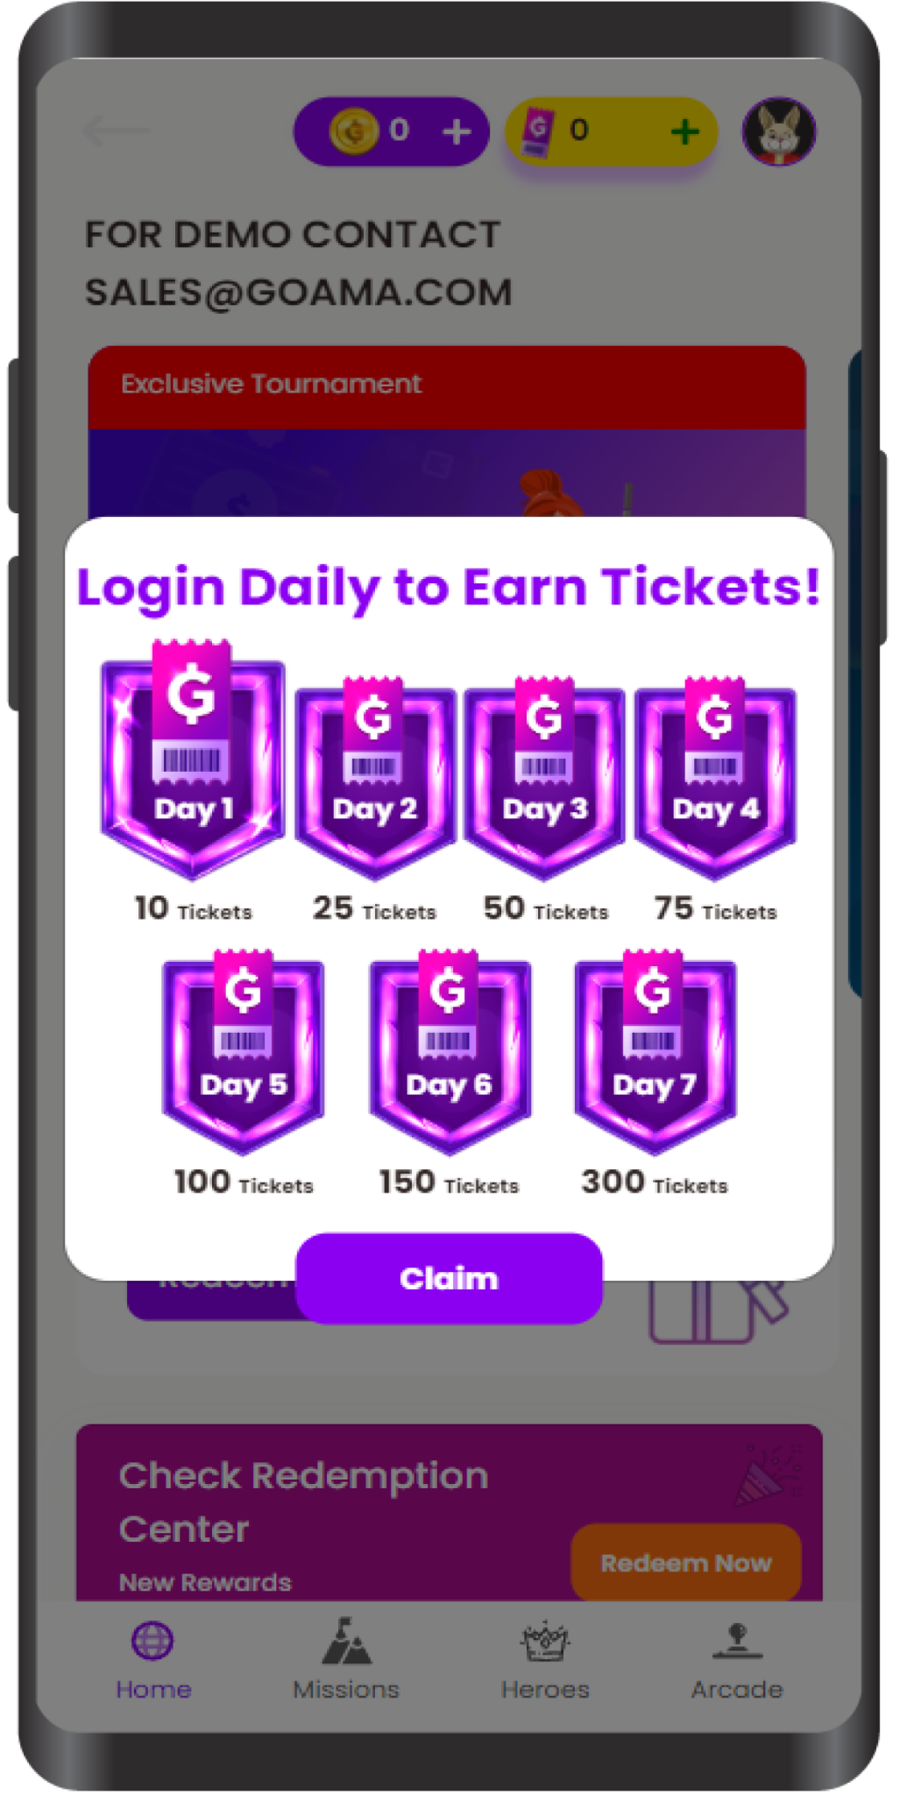

### Configurations & Setups

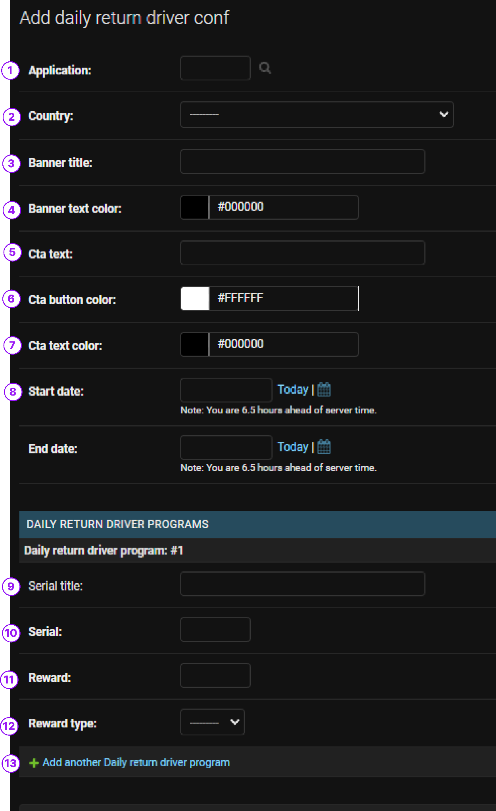

1. Select your preferred application to apply this feature
2. Select your preferred country to apply this feature
3. Name of the title of Daily Login Banner
4. Color of the title
5. CTA button text
6. Color of the CTA Button
7. Color of the text of CTA Button
8. Date range for this Daily Login banner to appear in the platform  
     
   Once basic info is set up, You must assign how many consecutive days the player must login into reap the rewards   
     
   Recommended structure   
   Every 3 days or Weekly
9. Title of the Series (i.e Day 1 )
10. Number of the Series (i.e 1)
11. Reward for login
12. Type of reward received

If wished to create a Daily login reward every week   
  
Create 7 serial (Day 1 to Day 7) serializing from 1 to 7

## Spin The Wheel

### User Journey

### Configuration & Setups

### Dynamic Distribution Algorithms

## Rewarded Ads

### User Journey

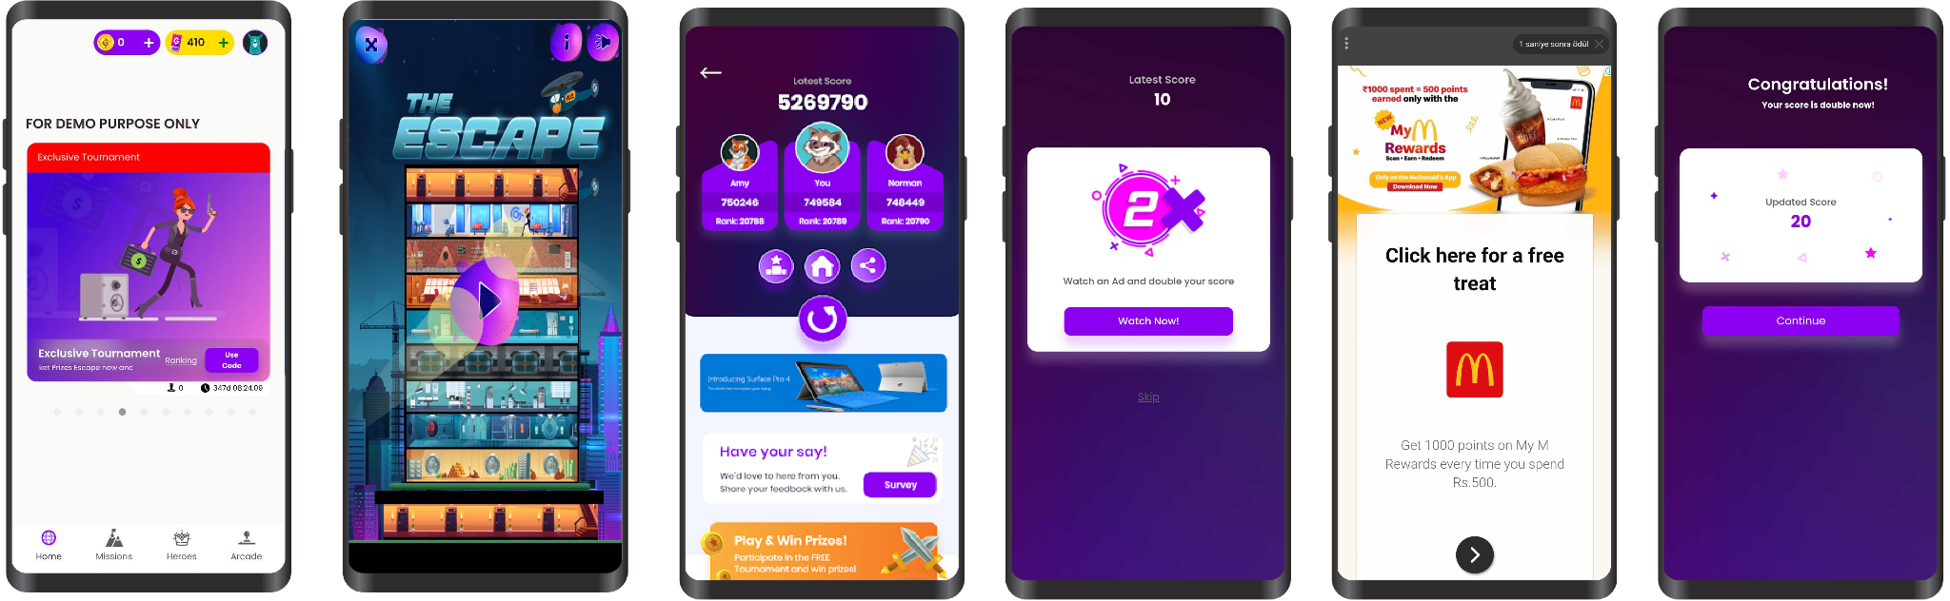

1. User Enter Platform
2. User choose and play game
3. User see gameover screen on post
4. Watch ads to double score prompted
5. User click watch and watch ads successfully
6. Highscore is updated.

### Configuration & Setups

**To enable rewarded ads, go to Django > Tournament > Check enable rewarded ad > Change increment score: 2X**

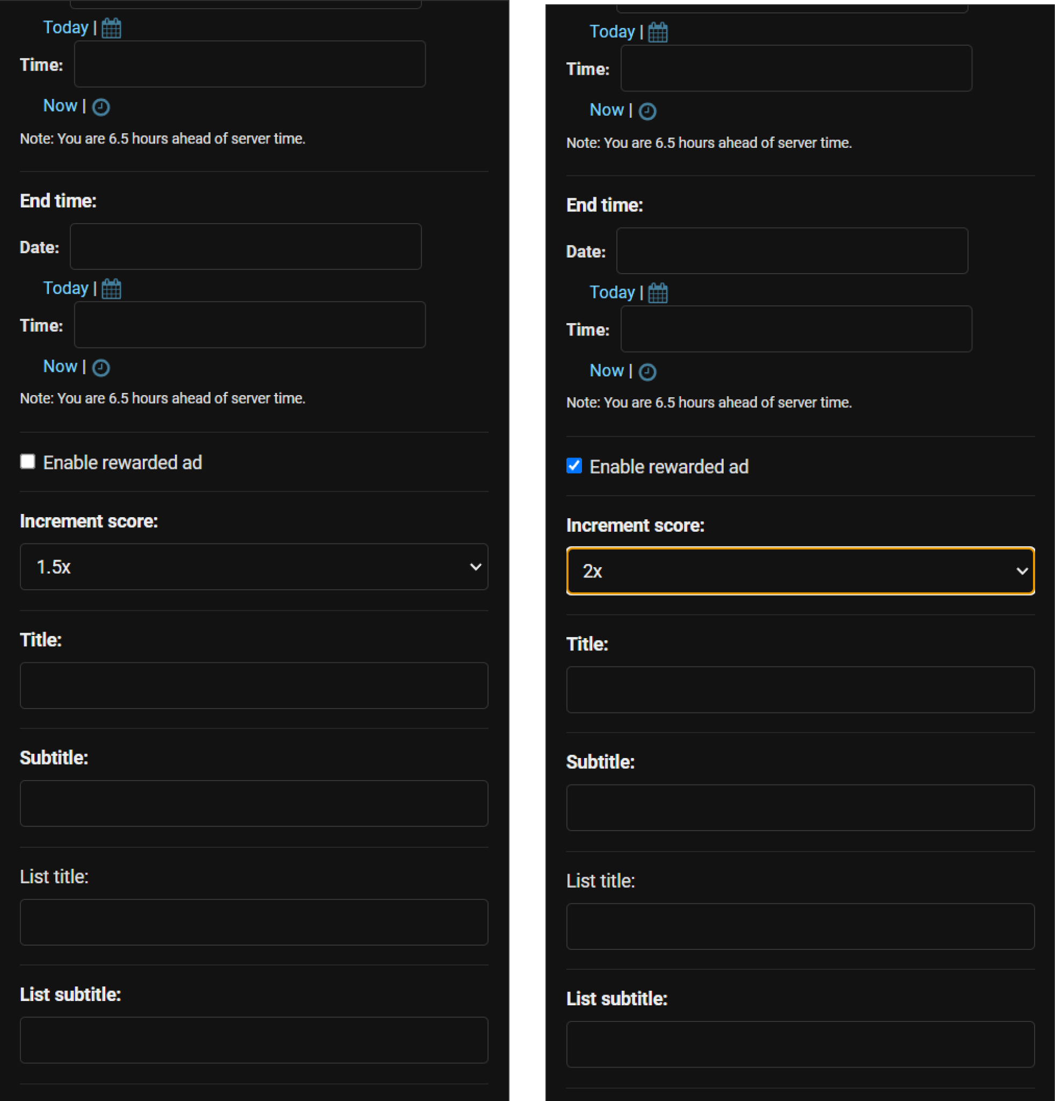

1. Enable rewarded ads
2. Change increment score to desired number(2x Default)
3. Save

# Social Platform

## Social Sharing

Social sharing options allow users to share their highscore via supported social media apps. Enabling this option, users will be able to see a button at the end of the game over screen where they can share to their friends or post on social media.

### User Journey

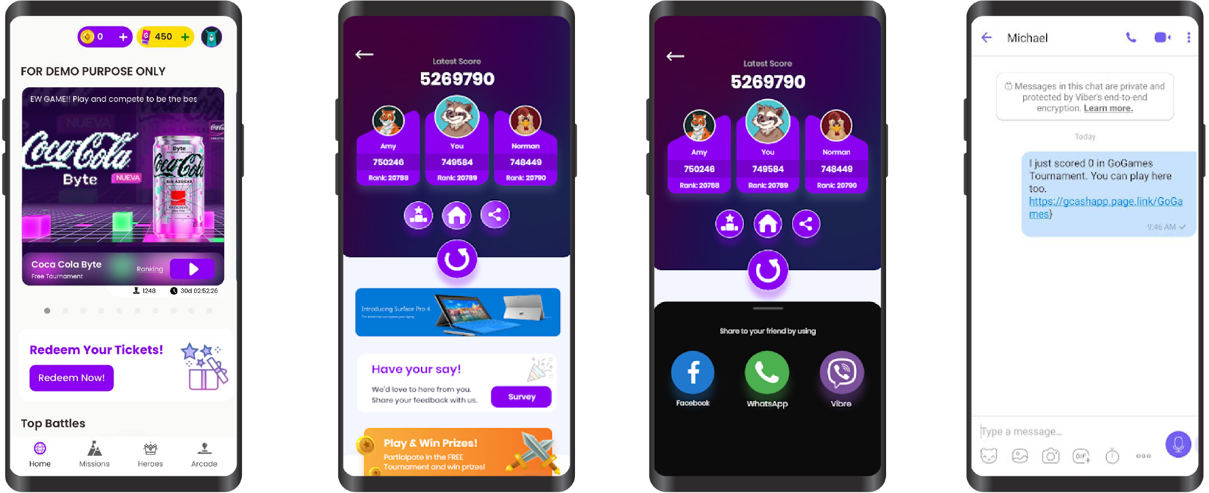

### Configurations & Setups

**Login to Django Panel > Under Tournaments Section > click on Application**

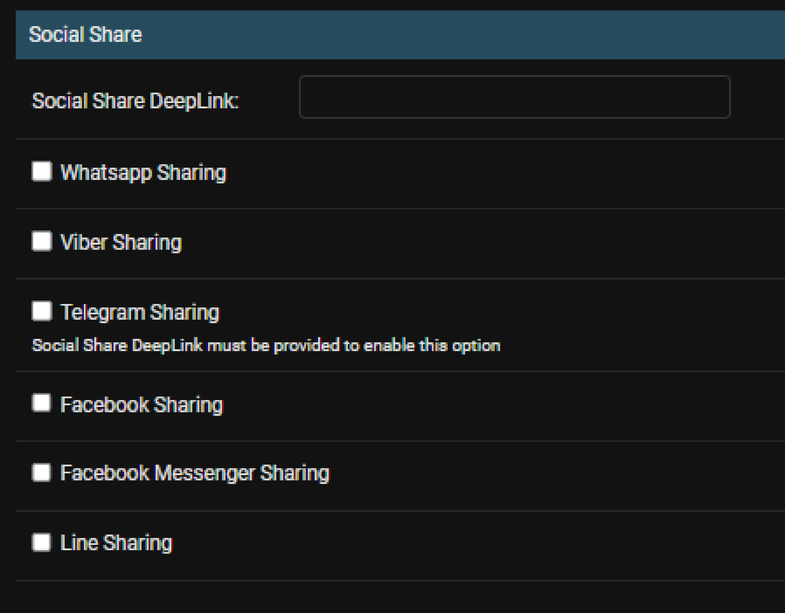

Simply check on the social media that you wish to enable social sharing option

## Invite a Friend Referral

### User Journey

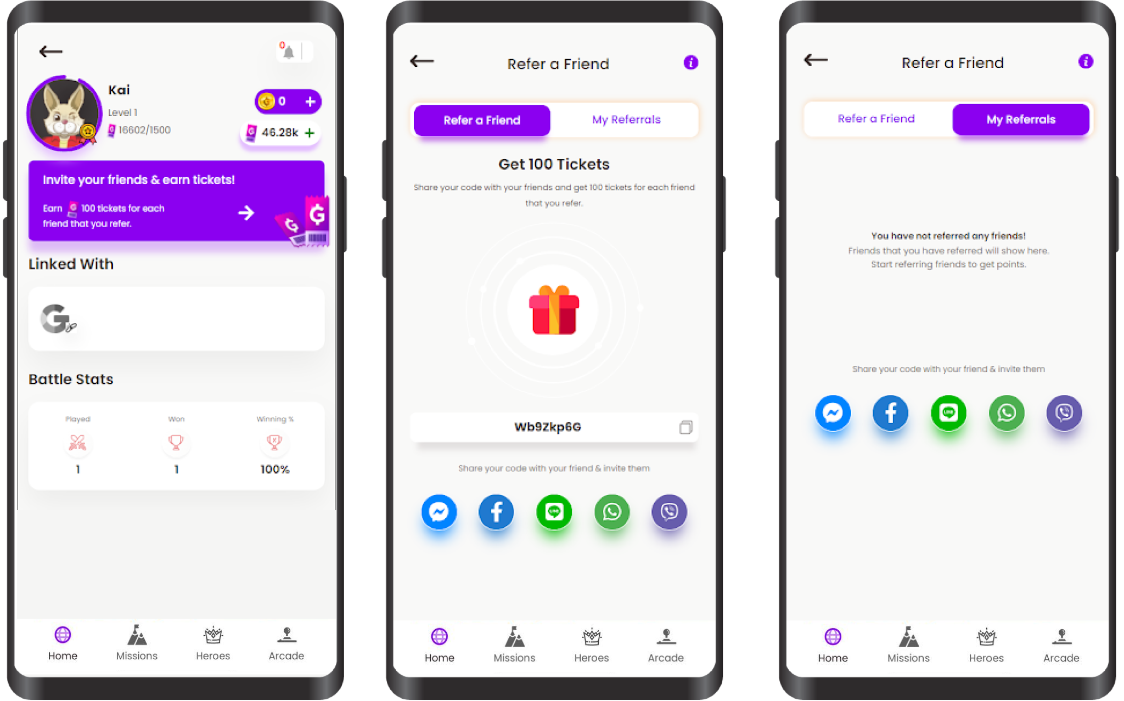

### Configurations & Setups

**Login to Django Panel > Under Users > click on Referral Template Configs**

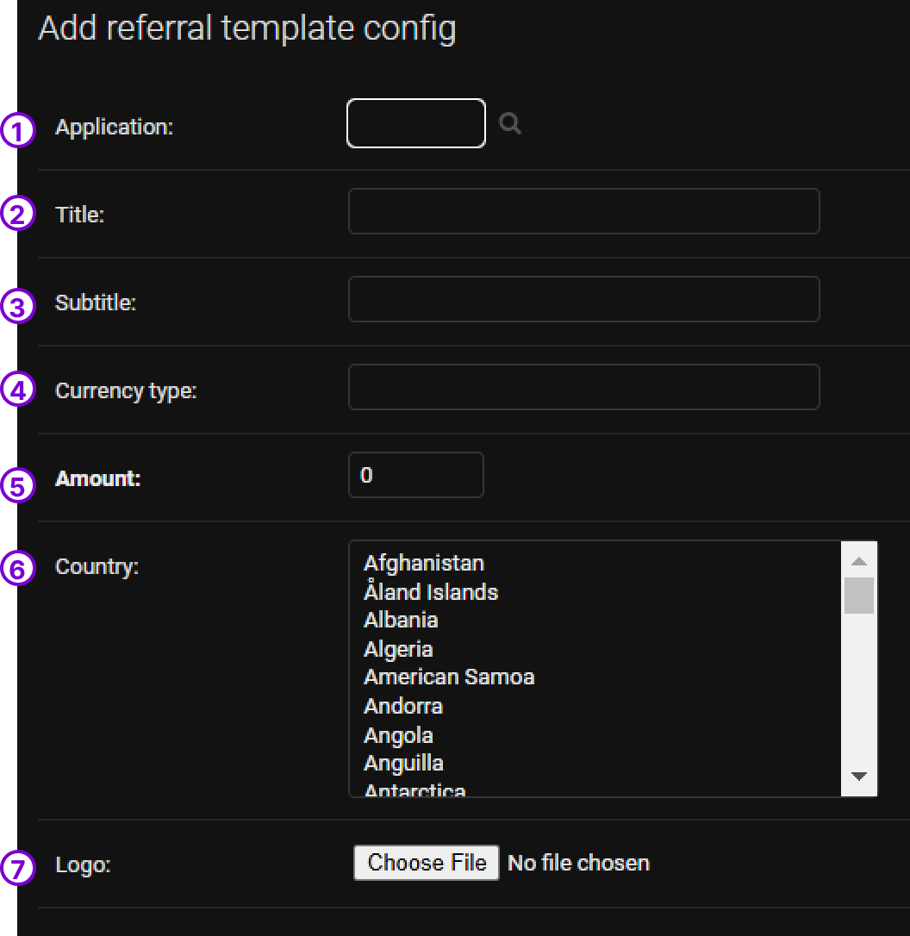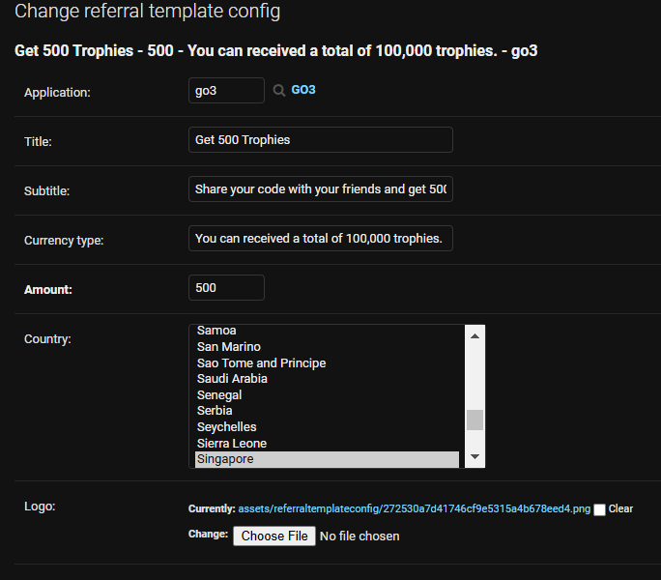

1. Select your preferred application to apply this feature
2. Title of the Referral
3. Sub-body text info of the referral
4. Input the text for total max amount of trophies a user can get
5. Select the Amount you would like to reward
6. Select the country to apply
7. Upload the logo of the currency

**Referral Configuration and User Journey**

**Configuration & setups**

1. Login to Django Admin panel
2. Navigate to User > User Referral Rule
3. Click on “Add new user referral rule” button
4. Set the target application
5. Set relevant title, subtitle, and max referral title in text
6. Set max received credit
7. Set referrer credit: how many tickets will be received by the user who is referring
8. Set user credit: how many tickets will be received by the user who is referred to

Then save  
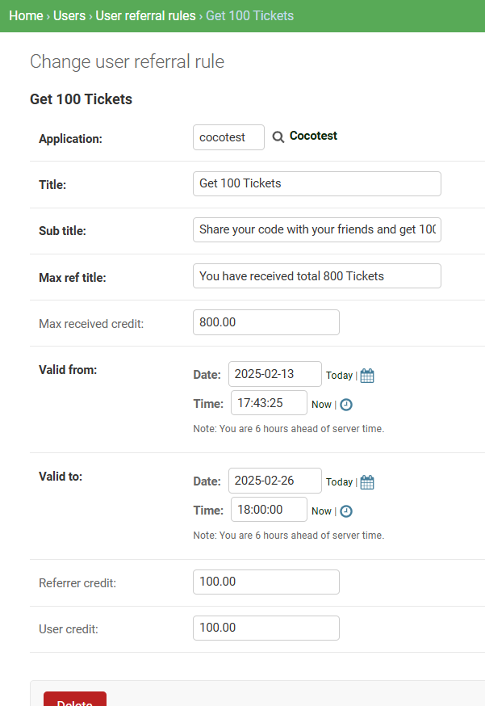

**Activate referral Deeplink in application**

Link setup

1. Navigate to Home › Tournaments › Applications › Desired application
2. Under application section search the application for the targeted application
3. Give the link by which user will refer(for telegram sharing)
4. Selects the social platforms by which user can share   
   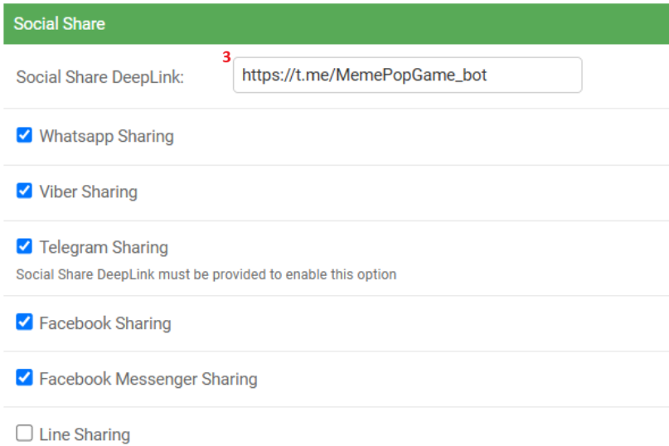

**In App referrer journey**

1. Navigate to the application list> User Profile page
2. Click on the arrow on the referral section  
   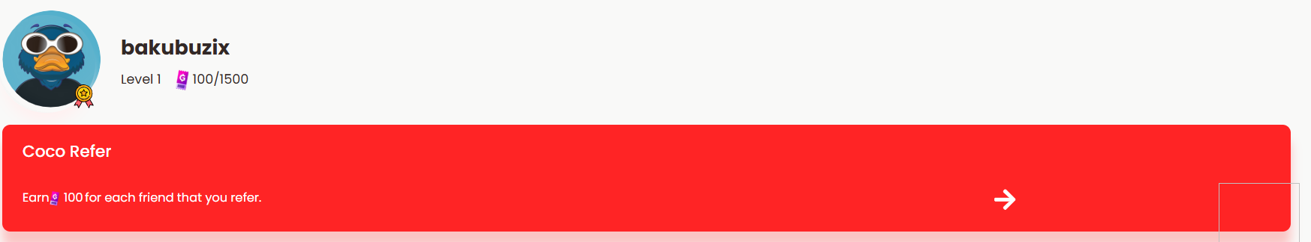
3. Either copy the code and share with friends, or click on the active social share icons to share with friends  
   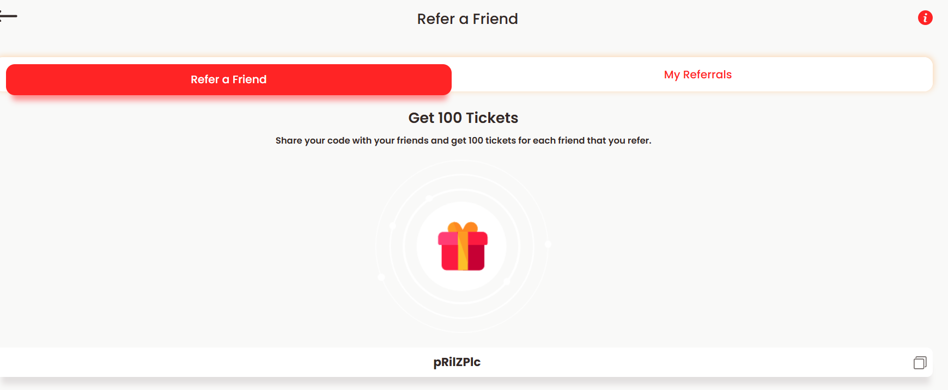  
   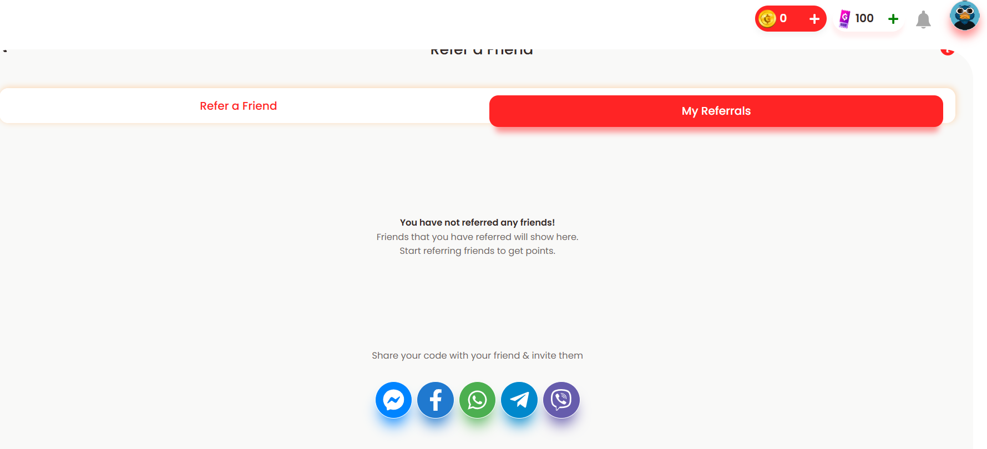
4. Then My Referrals tab will be updated and user will get promised tickets (only when the referred friend uses the referral code).

**User journey of who received the referral code**

1. Target user will navigate to the test application link> User Profile
2. Click on the Redeem a Code text on Referral Section  
   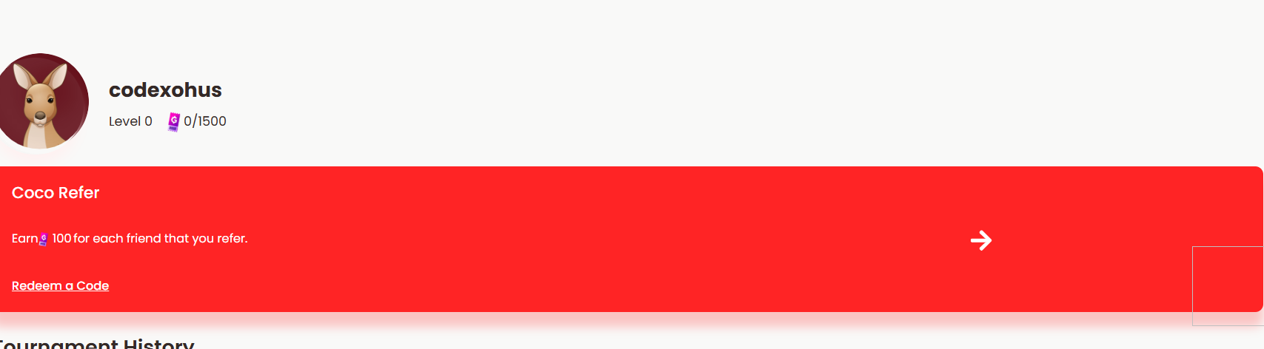
3. Enter the code and click on Apply Code button  
   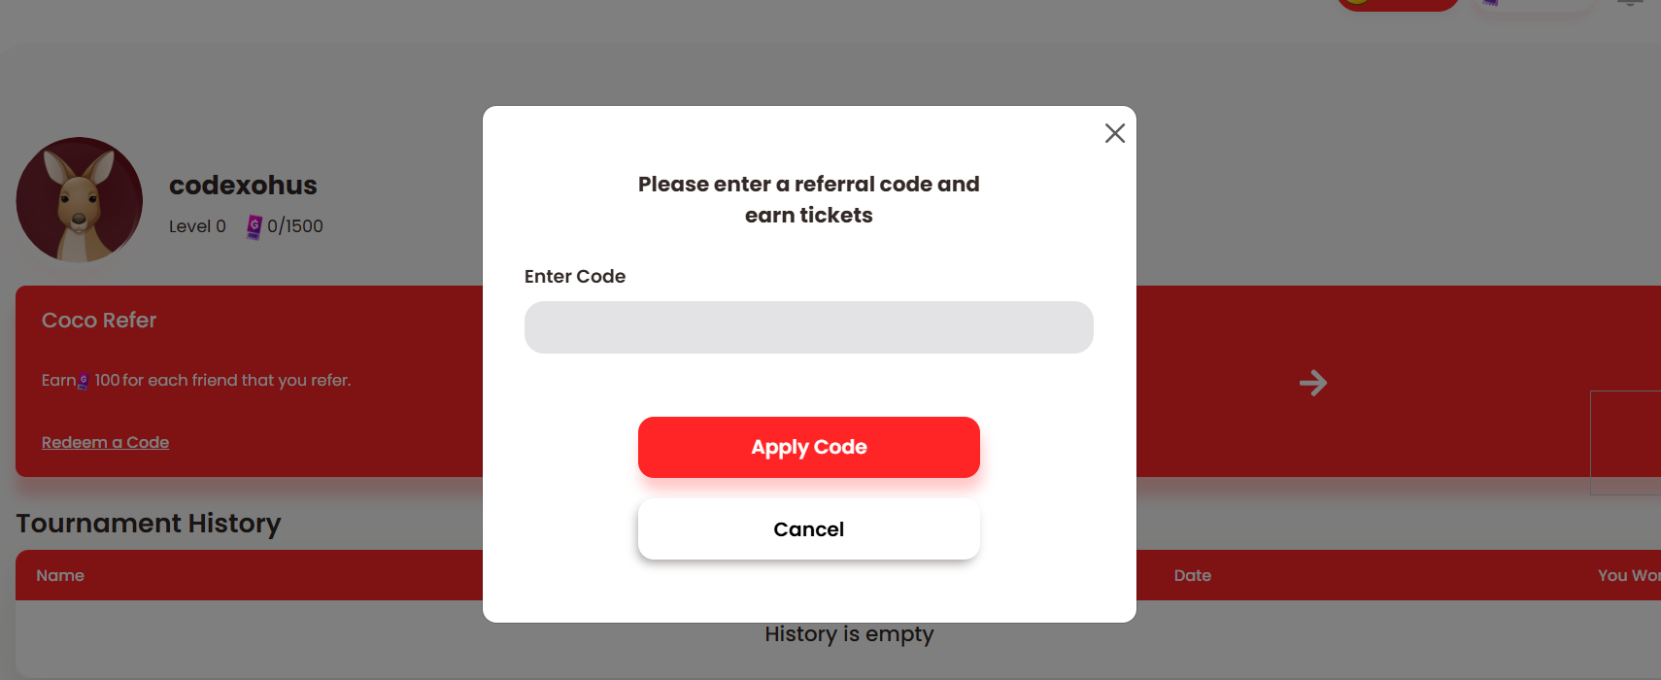

**Branding & Customization**

